CSS GENDER STUDIES
MA
The Master Anatomy
The paper, the record of 2016–2026, the seven topics, the method and the plan — the map you read before anything else
WHAT THIS DOCUMENT GIVES YOU
◆ Gender Studies from zero — the ideas, words, thinkers and timeline a complete beginner needs
◆ The paper explained — syllabus, reading list, structure, marks and minutes
◆ Every descriptive question (2016–2026) and all 140 recovered MCQs tagged, mapped and analysed
◆ The nine syllabus heads rebuilt into seven topics, each with a full dossier
◆ The method of a high-scoring answer, and a sixteen-week plan to the exam hall
Federal Public Service Commission · CSS Competitive Examination · Optional paper, 100 marks
Written for CE-2027 onwards · Record: CE-2016 to CE-2026 · Facts current to September 2026

Contents
HOW TO BUILD THE CONTENTS
The contents list below fills itself in. When Word asks "This document contains fields that may refer to other files. Update the fields?", click Yes.
If it does not ask: right-click the grey contents area → Update Field → Update entire table → OK. On a Mac, Control-click the same area. Or press Ctrl + A, then F9 (Windows), to update every field at once. Repeat after any edit, before you export to PDF.

Right-click here and choose Update Field to build the contents.

How to Use This Document

What this document is
This is not a textbook of Gender Studies. It teaches only as much of the subject as you need to find your way. It is the map you study before you study, and the map you come back to in the last fortnight, when you must decide what to revise.
It does six jobs:
1. It starts you from zero. Part Zero explains what Gender Studies is, the twelve ideas that unlock the whole subject, about a hundred words you must know, the thinkers you will meet, and the timeline behind the paper. It assumes you have never opened a book on the subject.
2. It explains the paper. What the syllabus says, which books help, how the paper is printed, how much time each question gets, and how marks are actually earned.
3. It dissects the record. Every descriptive question from CE-2016 to CE-2026 (77 questions, which become 84 items once the short notes are split) and all 140 recovered MCQs have been tagged by topic, by question family and by command word.
4. It rebuilds the syllabus. The nine syllabus heads are uneven. They are rebuilt into seven topics, each a unit you can master in two to three weeks, and each weighted by how often the examiner visits it.
5. It sets the method. How a Gender Studies answer is built: the answer map, headings taken from the question's own words, evidence inside every heading, diagrams, the Pakistan angle, the balanced view and the conclusion.
6. It gives you a plan. A sixteen-week timetable, a memory routine for the facts, and a minute-by-minute drill for the day of the paper.

Who it is written for
It is written for a candidate who has never studied Gender Studies. Perhaps you chose it because it is short, because it is useful for Essay and Current Affairs, or because a friend scored well in it. You may not know what "feminism" really means, what "patriarchy" is, or why anyone would say that "gender is socially constructed". That is fine. Every document in this set starts where you are.
- Every technical term is explained the first time it appears, and again in the word tables of Part Zero.
- Key terms you must be able to define are printed in bold green, like gender. Dates and numbers you must memorise are printed in bold navy, like 1972.
- The English is deliberately simple: short sentences, one idea in each. Where a thinker's own words are worth quoting in the exam, they are given exactly and then explained.
- Every idea is tied to an example, and wherever possible to an example from Pakistan.
IN SIMPLE WORDS
Think of this subject as a pair of glasses. Once you put them on, you start to notice that the same event — a flood, a budget, an election, a school timetable — affects women and men differently. Gender Studies is the discipline that explains why, and asks what can be done about it.

The family of documents
This Master Anatomy is the first document of the set. Each of the seven topics then gets two Word documents. When all seven are finished, five volumes are compiled from them.
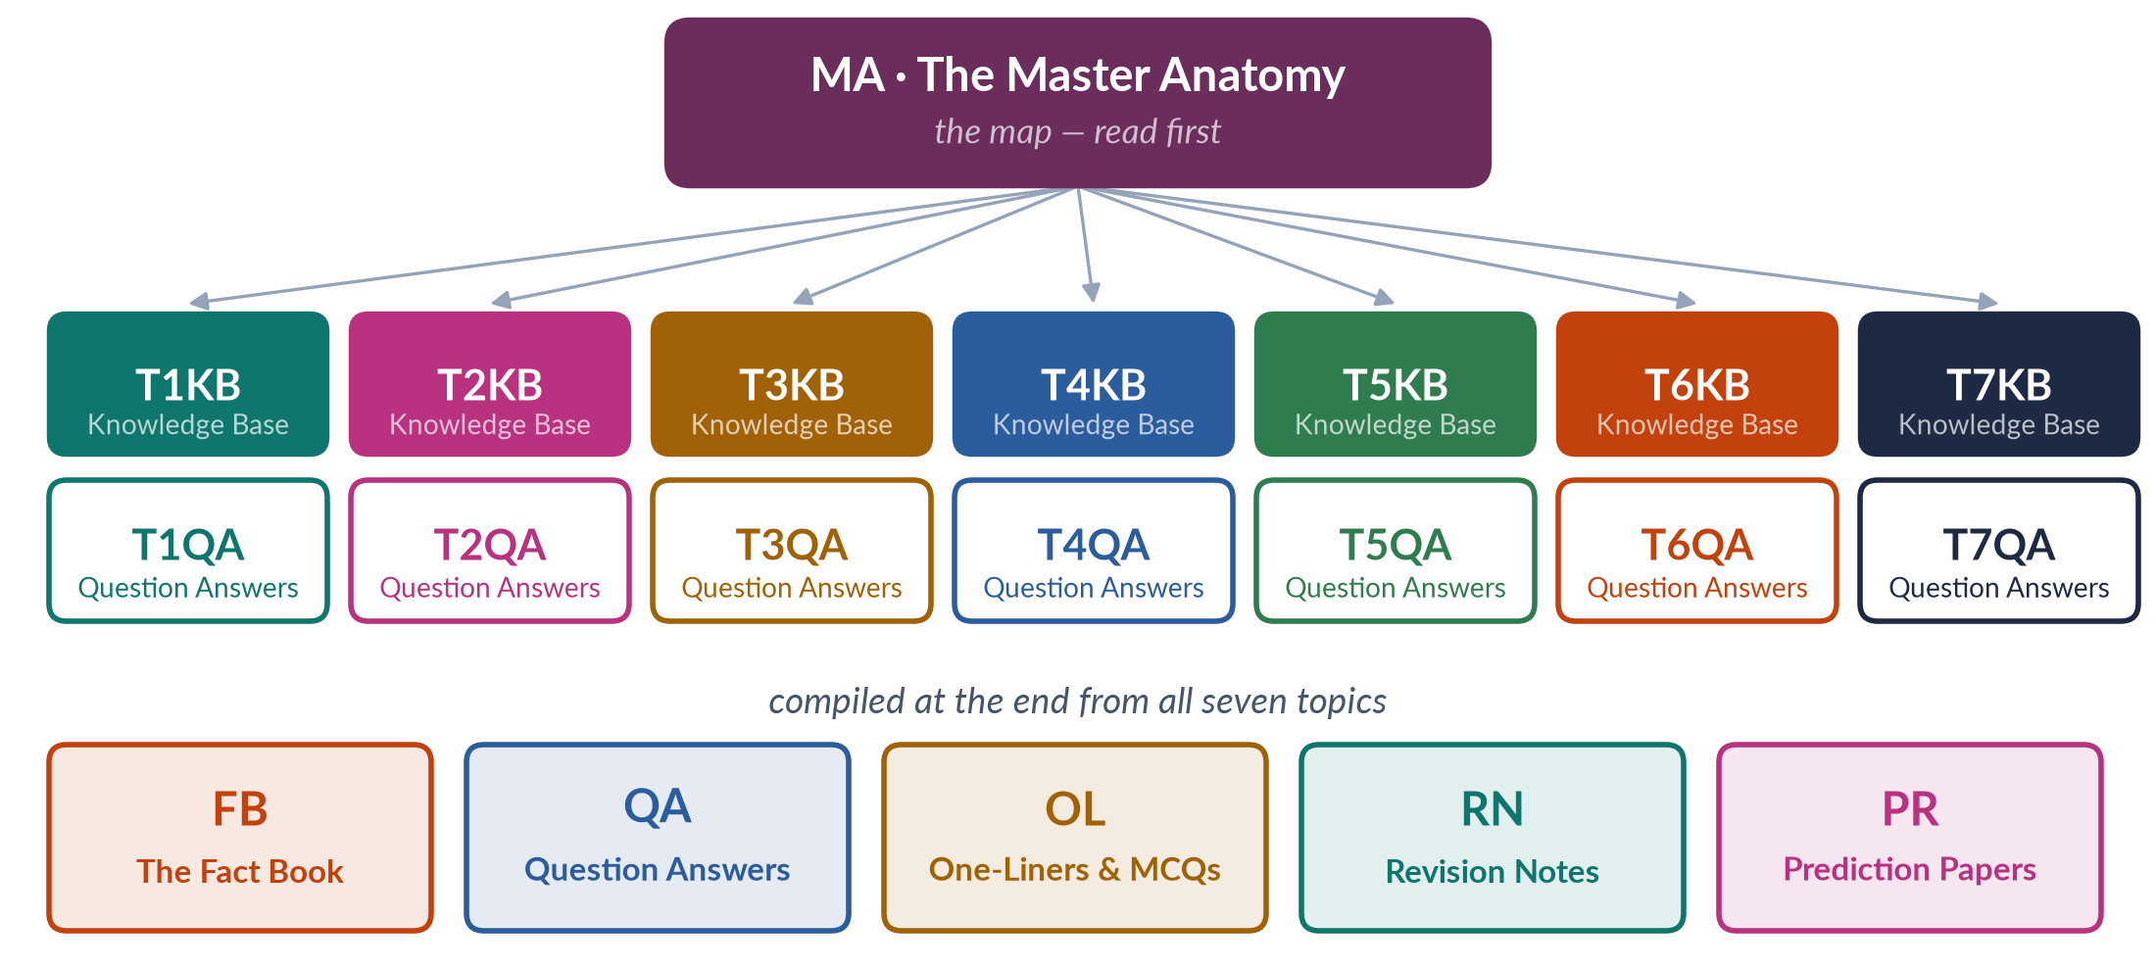
Figure 1 · The family of documents: one map, fourteen topic documents, five compiled volumes.
Table 1 · The documents of the set and what each one does.
Code | Document | What it does
MA | The Master Anatomy | This document: the subject from zero, the paper, the record, the seven topics, the method and the plan.
TnKB | Topic Knowledge Base (T1KB … T7KB) | Everything you need for the topic, taught from zero in simple English — a teaching core of 15,000–19,000 words each, plus the one-liner bank and revision sheet: key terms, chapters built from the syllabus lines and the examiner's questions, evidence cards inside every point, 10–18 diagrams, a chapter of contemporary debates, the topic's past questions and five likely questions, a bank of about 120 MCQ-style one-liners and a detailed revision sheet.
TnQA | Topic Question Answers (T1QA … T7QA) | Every past question of the topic answered as a model of 1,000–1,300 words: the answer map, a decoding of the question, headings from the question's own words, evidence in every heading, a diagram, the Pakistan angle and a conclusion.
FB | The Fact Book | Every fact, date, statistic, law, report, thinker, book, conference and case used anywhere in the set, arranged topic by topic and kept up to date — the book you memorise from.
QA | The Question Answers print volume | All seven TnQA documents in one volume, in syllabus order.
OL | The One-Liner and MCQ Bank | The one-liners of every KB, all 140 past MCQs with explained keys, and new practice MCQs on every syllabus line.
RN | The Revision Notes | The whole subject for the last three weeks — fuller than a summary: every topic's arguments, theories, facts and answer frames, in about 4,500 words per topic.
PR | The Prediction Papers (Sets 1–3) | Three complete papers set exactly as FPSC prints them — 20 MCQs and 7 descriptive questions each — with keys and full model answers.

How the pages are built
Every document in the set uses the same page furniture, so you always know what you are looking at. The most important piece is the evidence card. Evidence is what separates a 12-mark answer from a 16-mark one, and in this set evidence always sits inside the point it proves, never in a separate list at the end. There are seven kinds of card:
✦ DEFINITION
Gender · the core idea of the whole subject
The roles, behaviours, activities and attributes that a society considers appropriate for women and men. Gender is learnt, it changes over time, and it differs from one society to another.
➜ A teal card is a definition you should be able to reproduce in the exam, almost word for word.

✦ THINKER
Simone de Beauvoir · French philosopher · The Second Sex (1949)
"One is not born, but rather becomes, a woman."
➜ A plum card is a thinker's idea. When the exact words are well known they are quoted; when they are not, the idea is summarised in plain English — never invented.

✦ DATA
Global Gender Gap Report 2026 · World Economic Forum
Pakistan ranked 143rd of 145 economies, with 59.5% of its gender gap closed. In 2025 it had ranked last, 148th of 148.
➜ A blue card is data: a number, its source and its year. Data dates quickly, so every data card names its year, and the Fact Book is updated before each exam.

✦ LAW & POLICY
Criminal Law (Amendment) (Offences in the Name or Pretext of Honour) Act 2016 · Pakistan
Makes the punishment of life imprisonment compulsory in honour killings, even if the victim's family forgives the killer.
➜ A navy card is a law, a policy or an international convention, with its year and its key provision.

The other three cards are QUOTATION (a famous line from a report, a slogan or a leader), CASE (a real event or person, usually from Pakistan) and REPORT (the finding of an institution such as UN Women, HRCP or the World Bank).
Around the cards you will meet a set of boxes, each with one job:
Table 2 · The boxes and what each one means.
Box | What it means
IN SIMPLE WORDS | A hard idea retold as if to a friend. Read it first if the paragraph above it confused you.
EXAMPLE | The idea seen in real life — in a family, a village, an office, a law or a news story.
TRAP | A mistake candidates commonly make — a wrong date, a confused term, an argument that annoys examiners.
EXAMINER'S EYE | What the examiner is looking for in this question or topic, and how to give it to him or her.
HOT DEBATE | A live controversy — transgender rights, Aurat March, NGO-isation, climate, digital violence — set out fairly.
BALANCED VIEW | The main positions on a sensitive question, stated fairly, with the line a civil-service candidate should take.
PAKISTAN ANGLE | The Constitution, the laws, the institutions and the data that make an answer applied rather than abstract.
REMEMBER | A fact, list or line worth memorising word for word.
LATEST UPDATE | Something that changed in 2025–2026 which older books and notes do not have.

The rules these notes keep
Gender Studies deals with real people's lives, with law and with faith. You never know who your examiner is: a professor of sociology, a women's-rights activist, a retired civil servant or a religious scholar. Every document in this set therefore keeps six rules.
1. Accuracy first. Every date, number, law and quotation is checked. Where a number comes from a survey, the survey and its year are named. Where sources disagree, the notes say so.
2. Nothing invented. No quotation is put into anyone's mouth. No statistic is rounded into something it is not. Weak or doubtful "facts" that circulate in guidebooks are flagged, not repeated.
3. Balance. On contested questions — religion and women's rights, the Aurat March, the transgender law, Western versus local feminism — the notes present each side fairly and then give the reasoned, constitutional position a future civil servant can defend in any room.
4. The Pakistan angle everywhere. Every topic is applied to Pakistan: the Constitution of 1973, the laws, the institutions, the data and the cases. The examiner rewards application far more than theory recited from a Western textbook.
5. Up to date. The facts are current to September 2026 (for example, the Global Gender Gap Report 2026, the Labour Force Survey 2024–25, the Islamabad child-marriage law of 2025). The Fact Book carries the latest figures and is the place to refresh them before your exam.
6. Simple English. Short sentences. One idea per sentence. Every term explained. If a sentence needs to be read twice, it has been rewritten.
EXAMINER'S EYE · WHY BALANCE SCORES
An answer that shouts — at the West, at religion, at men, at "feminists" — loses marks with every kind of examiner. An answer that defines its terms, presents evidence, admits the strongest counter-argument and then reaches a reasoned conclusion wins marks with all of them. Balance is not a lack of opinion. It is an opinion that has earned the right to be heard.

The reading order
1. Read Part Zero slowly. It is Gender Studies from zero: the ideas, the vocabulary, the thinkers and the whole syllabus in twenty minutes. Come back to its word tables whenever a term puzzles you.
2. Read Parts One to Three once, quickly. They explain the paper and the record. You do not need to memorise them.
3. Read a topic's dossier in Part Four just before you begin that topic's Knowledge Base.
4. Read Part Five (method) before you write your first practice answer, and again before your first prediction paper.
5. Return to Part Three and Part Six in the last fortnight to decide what to revise and how to spend the day of the paper.

Part Zero — Gender Studies from Zero
Before you can answer a single question, you need the ideas, the words and the story of the subject. This part gives you all three, assuming you start from nothing.

0.1 What this subject is — and what it is not
Gender Studies is the academic study of how societies turn biological males and females into "men" and "women", what roles and values they attach to each, and how these arrangements create inequality in power, resources and opportunity. It also studies people who do not fit neatly into two categories, and it asks how things could be made fairer.
It grew out of an older field, Women's Studies, which was born in American universities around 1969–1970 as the academic arm of the women's movement. Women's Studies asked: where are the women in history, literature, economics and politics? Gender Studies, which spread from the 1980s, widened the question: how do femininity and masculinity work, how do they relate to each other, and how do they combine with class, race, religion and sexuality?
IN SIMPLE WORDS
Women's Studies puts women at the centre of the picture. Gender Studies looks at the whole picture — women, men and everyone else — and at the relationships between them.

The subject is multidisciplinary: it borrows tools from sociology, anthropology, psychology, history, economics, political science, law, literature, biology and development studies. That is why the CSS paper can move from Freud (psychology) to structural adjustment (economics) to the Hudood Ordinances (law) to Malala Yousafzai (a living case study) in a single sitting.
Table 3 · What the paper is — and what it is not.
The paper IS … | The paper is NOT …
a test of concepts — gender, patriarchy, social construction, feminism, empowerment, intersectionality | a test of opinions about men and women
a test of theory — the schools of feminism, the development theories, the theories of violence | a sermon for or against feminism
a test of application — health, education, work, law, politics and violence in Pakistan | a Western textbook recited without Pakistan in it
a test of evidence — thinkers, data, laws, reports and cases | a collection of emotional statements
a test of structure — headings, diagrams, a clear argument and a balanced conclusion | a test of memorising long paragraphs

0.2 Sex and gender — the first distinction
Everything in this subject begins with one distinction. It was first made in psychology by Robert Stoller (Sex and Gender, 1968) and brought into sociology by the British sociologist Ann Oakley in Sex, Gender and Society (1972).
✦ DEFINITION
Sex · biological difference
The biological and physiological characteristics that distinguish females and males: chromosomes (usually XX or XY), hormones, and reproductive organs.
➜ Sex is mostly given by birth and is broadly similar across societies.

✦ DEFINITION
Gender · social difference
The roles, behaviours, expectations, identities and power that a society attaches to being female or male.
➜ Gender is learnt, it varies between societies, and it changes over time — which means it can be changed by policy, law and education.

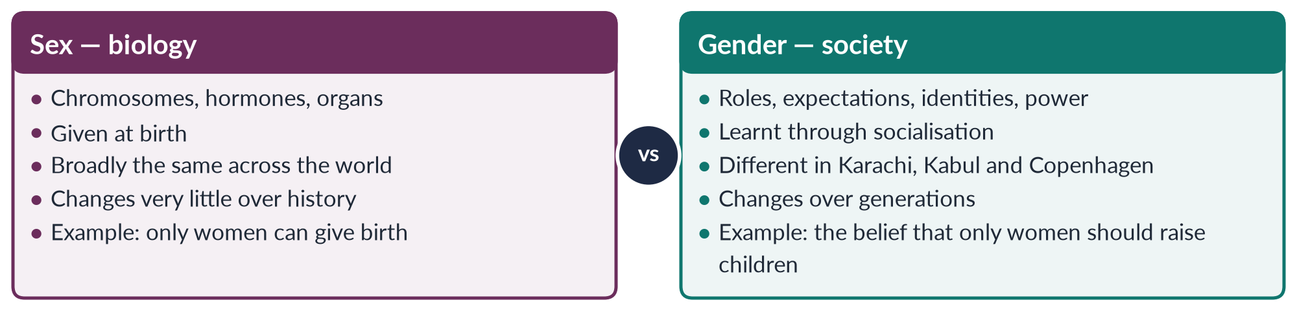
Figure 2 · Sex and gender compared: the distinction on which the whole subject rests.
EXAMPLE · THE SAME BODY, DIFFERENT GENDERS
In rural Punjab, a girl may be expected to stay at home after puberty, to help with cooking and cattle, and to marry young. In Islamabad, a girl of the same age may attend a co-educational university and plan a career. Their bodies — their sex — are the same. What their families and communities expect of them — their gender — is very different. That difference is what Gender Studies studies.

The distinction was a breakthrough because it separated what is fixed from what is changeable. If women earn less because of biology, nothing can be done. If they earn less because of gender — because of social rules about who works outside the home — then those rules can be changed.
Later thinkers went further. Judith Butler (Gender Trouble, 1990) and the queer theorists asked whether even "sex" is partly social: who decides that there are exactly two sexes, and what of intersex people born with characteristics of both? This debate — asked in CSS 2018, 2024 and 2026 — is taught fully in Topic 1.
TRAP · TWO DEBATES, NOT ONE
The sex versus gender debate asks what is biological and what is social. The nature versus nurture debate asks why women and men behave differently: because of genes and hormones, or because of upbringing and culture. The two are linked, but they are not the same question. Name both separately when a question mentions either.

0.3 The twelve ideas that unlock the whole subject
If you understand these twelve ideas, you can follow any chapter in these notes. Each is taught fully in its topic; here you meet them once, simply.
1. Patriarchy — literally "the rule of the father". A social system in which men hold most of the power in the family, the economy, politics and religion, and in which male authority is treated as natural. Almost every theory in this subject is a theory of patriarchy: where it comes from and how it can end.
2. Gender roles — the tasks and behaviours a society assigns to each gender. The man as breadwinner and the woman as homemaker is the classic pair.
3. Socialisation — the process by which children learn their gender roles from family, school, religion, media and friends. A boy told "boys don't cry" is being socialised.
4. Social construction — the idea that something which looks natural is in fact made by society. To say "gender is socially constructed" is to say it was built by people, and so can be rebuilt.
5. The sexual division of labour — the split of work into "men's work" (paid, public, valued) and "women's work" (unpaid, domestic, invisible). Care work in the home is the largest unpaid industry in the world.
6. Public and private spheres — the public sphere is politics, markets and paid work; the private sphere is home and family. Patriarchy has kept women in the private sphere. Feminists answered: "the personal is political" — what happens at home is shaped by power too.
7. Masculinity and femininity — the qualities a society expects of men (strength, control, providing) and of women (care, modesty, obedience). There are many masculinities; the dominant one, which Raewyn Connell called hegemonic masculinity, is held up as the ideal and harms women and many men.
8. Feminism — the belief that women and men should have equal rights and opportunities, and the movement to achieve it. There are many feminisms (liberal, radical, Marxist, and more), which agree that women are disadvantaged but disagree about why and what to do.
9. Intersectionality — a term coined by Kimberlé Crenshaw in 1989. Gender never works alone: a poor, rural, minority woman faces gender plus class plus religion plus location, and these overlap to produce a unique disadvantage.
10. Empowerment — the process by which people who have been denied power gain the ability to make choices about their own lives. Naila Kabeer describes it through three linked parts: resources, agency and achievements.
11. Gender mainstreaming — the strategy, adopted globally at the Beijing Conference in 1995, of checking every law, policy, budget and project for its effect on women and men before it is approved.
12. Gender-based violence (GBV) — violence directed at a person because of their gender, or which affects one gender disproportionately. The World Health Organization estimates that about 1 in 3 women worldwide experiences physical or sexual violence in her lifetime.
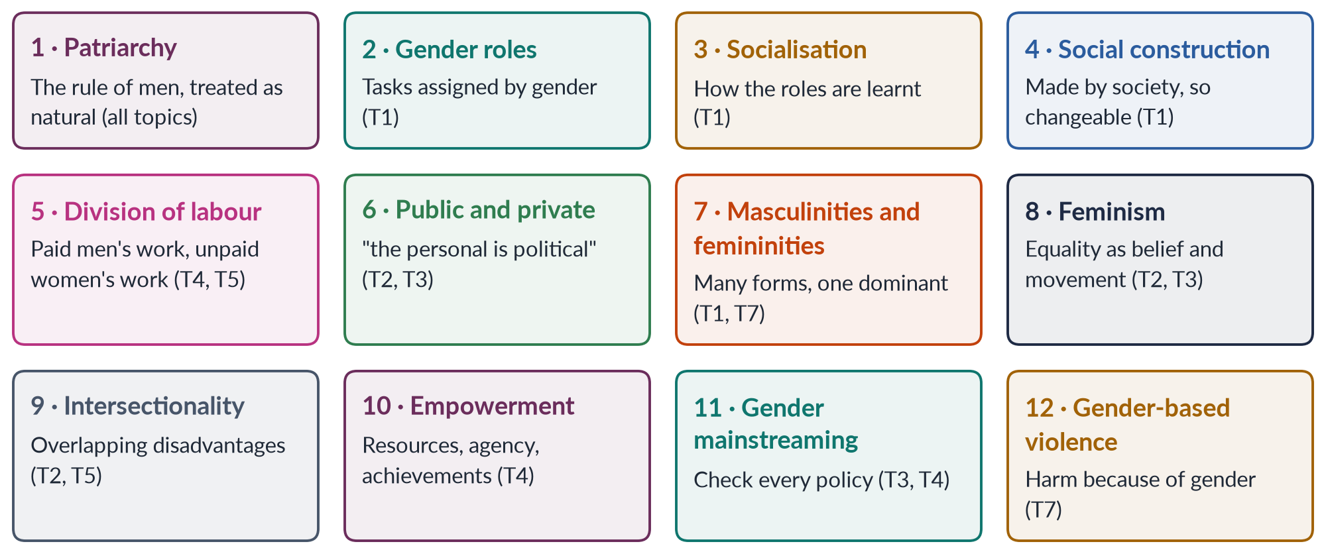
Figure 3 · The twelve ideas that unlock the subject — each is taught in full in the topic shown.
REMEMBER · THE TWELVE IDEAS IN ONE LINE EACH
Patriarchy (male rule) · gender roles (assigned tasks) · socialisation (learning them) · social construction (made, not born) · division of labour (paid and unpaid) · public/private (and the personal is political) · masculinities/femininities (many, one dominant) · feminism (equality as belief and movement) · intersectionality (overlapping disadvantages) · empowerment (gaining choice) · mainstreaming (checking every policy) · GBV (violence because of gender).

0.4 The words you must know before anything else
The tables below give about a hundred terms, grouped by the topic in which each is taught. A star (★) marks a term you must be able to define in one sentence in the exam. Tick each term when you can explain it to a friend without looking.

Topic 1 · The discipline and the social construction of gender
Term | Meaning
Gender Studies ★ | The multidisciplinary study of how gender is made, how it shapes power and life chances, and how it intersects with other identities.
Women's Studies ★ | The academic field, begun around 1969–70, that makes women the subject and the knowers of research, as part of the women's movement.
Multidisciplinary ★ | Drawing on many disciplines at once — sociology, psychology, economics, law, history, biology, literature.
Autonomy versus integration ★ | The debate over whether Women's/Gender Studies should be a separate department (autonomy) or be woven into every existing discipline (integration). Framed by Bowles and Klein (1983).
Androcentrism | Treating the male as the norm and the female as a deviation, as when medicine tested drugs only on men.
Social constructionism ★ | The theory that what seems natural (gender, even aspects of sex) is produced by social processes, language and history.
Essentialism | The opposite view: women and men have fixed, natural essences that explain their behaviour.
Biological determinism | The belief that biology alone decides behaviour and social roles.
Gender identity ★ | A person's inner sense of being a woman, a man, both, or neither.
Gender roles / norms ★ | The behaviours expected of each gender; norms are the unwritten rules that enforce them.
Socialisation ★ | Learning the norms of one's society, including gender norms, from family, school, media and religion.
Masculinity / femininity ★ | The sets of qualities a culture expects of men and of women.
Hegemonic masculinity ★ | Connell's term for the dominant, idealised form of masculinity that legitimates men's power over women and over "lesser" men.
Androgyny | Having both masculine and feminine traits; Sandra Bem (1974) argued androgynous people are the most adaptable.
Queer theory ★ | A theory from about 1990 (de Lauretis, Butler, Sedgwick) that questions fixed categories of sex, gender and sexuality and the norm of heterosexuality.
Performativity ★ | Butler's idea that gender is not something we are but something we repeatedly do; the repetition creates the illusion of a natural core.
Doing gender | West and Zimmerman's (1987) idea that gender is accomplished in everyday interaction.
Heteronormativity | The assumption that heterosexuality is the only normal sexuality and that gender comes in two opposite forms.
Intersex | Born with sex characteristics that do not fit typical definitions of male or female.
Transgender / khawaja sira | A person whose gender identity differs from the sex recorded at birth. Khawaja sira is the traditional South Asian term for gender-variant communities, recognised by Pakistan's Supreme Court in 2009.
Gendered language | Language that encodes gender bias, e.g. "chairman", "mankind", or Urdu idioms that praise men as brave and women as modest.

Topic 2 · Feminist theories
Term | Meaning
Feminism ★ | The belief in the social, political and economic equality of the sexes, and the movement to achieve it.
Liberal feminism ★ | Equality through equal rights, laws, education and opportunity within the existing system (Wollstonecraft, Mill, Friedan).
Radical feminism ★ | Patriarchy is the deepest oppression; it runs through family, sexuality and culture, so society must be transformed at the root (Millett, Firestone).
Marxist feminism ★ | Women's oppression comes from class society and private property; it will end with capitalism (Engels).
Socialist feminism ★ | Capitalism and patriarchy are two linked systems — "dual systems" — and both must be fought (Hartmann, Mitchell).
Psychoanalytic feminism ★ | Gender inequality is rooted in early childhood and the unconscious mind; it revises Freud (Horney, Chodorow, Mitchell).
Postmodern feminism ★ | There is no single "woman" or single truth; identities are made in language and discourse (Butler, Cixous, Irigaray, Kristeva).
Men's feminism / pro-feminism ★ | Men who support feminist goals and study how patriarchy shapes men (Connell, Kimmel; UN Women's HeForShe, 2014).
Black feminism | Feminism that centres the experience of Black women facing race, gender and class together (hooks, Collins, Crenshaw).
Postcolonial feminism | Critiques Western feminism for speaking for "Third World women" (Mohanty, Spivak).
Ecofeminism | Links the domination of women with the domination of nature (d'Eaubonne, 1974; Shiva).
Muslim / Islamic feminism | Seeks gender justice through re-reading Islamic sources (Amina Wadud, Fatima Mernissi, Riffat Hassan).
Misogyny | Hatred of, or contempt for, women.
Standpoint theory | Knowledge is shaped by social position; women's lived experience gives insight that dominant groups miss (Harding, Hartsock).
Écriture féminine | "Women's writing" — Hélène Cixous's call for writing from the female body and experience (1975).
Kyriarchy | Elisabeth Schüssler Fiorenza's term for interlocking systems of domination (gender, race, class, empire).
Matrix of domination | Patricia Hill Collins's (1990) term for how intersecting oppressions are organised across society.
Patriarchal bargain | Deniz Kandiyoti's (1988) term for the strategies women use to secure what they can within patriarchy.

Topic 3 · Feminist movements
Term | Meaning
Wave ★ | A period of intense feminist activity. First (c. 1848–1920: the vote), second (1960s–80s: equality in work, family, body), third (1990s–2000s: diversity), fourth (c. 2012–: digital activism, #MeToo).
Suffrage ★ | The right to vote. Suffragists campaigned lawfully; "suffragettes" (WSPU, from 1903) used militant tactics.
Seneca Falls Convention ★ | The 1848 meeting in New York, led by Elizabeth Cady Stanton and Lucretia Mott, that issued the Declaration of Sentiments.
CEDAW ★ | The UN Convention on the Elimination of All Forms of Discrimination against Women (adopted 1979; in force 1981) — "an international bill of rights for women". Pakistan acceded in 1996.
Beijing Platform for Action ★ | The plan adopted at the Fourth World Conference on Women, 1995: twelve critical areas of concern, and gender mainstreaming.
APWA ★ | All Pakistan Women's Association, founded in 1949 by Begum Ra'ana Liaquat Ali Khan — welfare-based activism.
WAF ★ | Women's Action Forum, founded in 1981 to resist Zia-ul-Haq's discriminatory laws; the 12 February 1983 Lahore protest is its defining moment.
Aurat March ★ | Annual marches on International Women's Day (8 March), held in Pakistan since 2018.
NGO-isation ★ | The process by which a social movement turns into donor-funded, professionalised NGOs doing projects — often said to depoliticise it (Alvarez; Jad).
#MeToo | The movement against sexual harassment that went global in 2017 (the phrase was first used by Tarana Burke in 2006).
State feminism | Women's rights promoted from above by the state, e.g. Ayub Khan's Muslim Family Laws Ordinance of 1961.

Topic 4 · Gender and development
Term | Meaning
Development ★ | The process of improving people's lives — income, health, education, freedom. Gender analysis asks: development for whom?
Modernisation theory ★ | Poor countries develop by copying the path of the West — industry, cities, "modern" values (Rostow, 1960). Critics: women were left out.
Dependency theory ★ | Poor countries (the periphery) are kept poor by rich countries (the core) through unequal trade (Frank, Prebisch).
World-system theory ★ | Immanuel Wallerstein's (1974) view of one capitalist world economy of core, semi-periphery and periphery.
Structural functionalism ★ | Society is a system of parts that keep it stable; Parsons saw men's "instrumental" and women's "expressive" roles as functional.
WID ★ | Women in Development (1970s): add women to development projects; inspired by Ester Boserup (1970).
WAD ★ | Women and Development (late 1970s): women were always in development — but on unequal, exploitative terms set by global capitalism.
GAD ★ | Gender and Development (1980s): change the unequal power relations between women and men, not just women's condition.
Practical gender needs ★ | Immediate needs within existing roles — water, health care, income (Molyneux 1985; Moser 1989/1993).
Strategic gender interests ★ | Long-term needs that change women's position — legal rights, ending violence, equal voice.
Triple role | Moser's idea that women do reproductive, productive and community-managing work.
SAPs ★ | Structural Adjustment Programmes/Policies: IMF and World Bank loan conditions (from the 1980s) — cutting subsidies and spending — which fell hardest on women.
Globalisation ★ | The growing interconnection of economies and cultures across the world.
Feminisation of labour / poverty | More women drawn into low-paid, insecure work; more of the poor being women.
Global care chain | Arlie Hochschild's term for women migrating to care for richer families while others care for their own children.
Coloniality | The idea that colonial power relations continue after independence, including through "development" (Quijano, Lugones, Escobar).
Gender budgeting | Analysing a budget for its impact on women and men.

Topics 5 and 6 · Women in Pakistan; gender and governance
Term | Meaning
Maternal mortality ratio ★ | Deaths of women from pregnancy-related causes per 100,000 live births. Pakistan: 186 (Pakistan Maternal Mortality Survey, 2019).
Female labour force participation ★ | The share of working-age women who are working or looking for work. Pakistan: 24.4% (Labour Force Survey 2024–25).
Gender parity index | The ratio of girls to boys in school; 1.0 means equality.
Glass ceiling ★ | The invisible barrier that stops women rising to the top of organisations.
Sticky floor / glass cliff | Women stuck in low-paid jobs / women promoted to leadership in a crisis, when failure is likely.
Informal sector | Unregistered work without contracts or protection — home-based workers, domestic workers, agricultural labour.
Governance ★ | The way power is exercised in managing a country's resources and affairs: participation, accountability, transparency, rule of law.
Quota ★ | A share of seats or posts reserved for women. Pakistan: 60 of 336 National Assembly seats (since 2002; 60 of 342 before the 2018 merger of FATA changed the total).
Critical mass | The idea that women must form about 30% of a body before they can change its agenda (Dahlerup).
Descriptive vs substantive representation ★ | Women being present in parliament vs women's interests actually being advanced there.
Glass wall | Barriers that confine women to "soft" ministries like women's affairs and social welfare.

Topic 7 · Gender-based violence
Term | Meaning
Violence against women ★ | "Any act of gender-based violence that results in, or is likely to result in, physical, sexual or psychological harm or suffering to women" (UN Declaration, 1993).
Direct violence ★ | Visible violence with an identifiable perpetrator — beating, rape, acid attack, murder (Galtung).
Structural violence ★ | Harm built into social structures — poverty, discriminatory laws, lack of health care — with no single perpetrator (Galtung, 1969).
Cultural violence | Beliefs, customs and language that make direct and structural violence look normal (Galtung, 1990).
Honour killing ★ | The murder of a woman (or man) by relatives who believe she has brought "dishonour" on the family.
Domestic violence ★ | Abuse within the home — physical, sexual, psychological or economic.
Power and control wheel | The Duluth model (1981) showing how abusers use intimidation, isolation and economic control to dominate.
Cycle of violence | Lenore Walker's (1979) pattern: tension builds, incident, reconciliation, calm — and again.
Vani / swara | Giving girls in marriage to settle disputes between families; criminalised in Pakistan (2004 and 2011).
Jirga / panchayat | Informal councils of elders that sometimes order punishments against women, as in the Mukhtaran Mai case.
Technology-facilitated GBV | Online harassment, blackmail, image abuse and stalking; covered in Pakistan by PECA 2016.

0.5 The thinkers you will meet
You do not need to memorise all of these now. But when a name appears in a Knowledge Base, come back to this table to see where the thinker fits. Quoting the right thinker in the right place is one of the cheapest ways to earn marks.
Table 4 · Forty names that carry the subject.
Thinker | Main idea | Key work (year) | Topic
Mary Wollstonecraft | Women are not naturally inferior; they lack education | A Vindication of the Rights of Woman (1792) | T2
John Stuart Mill (with Harriet Taylor) | Legal subordination of women is wrong and harms society | The Subjection of Women (1869) | T2
Friedrich Engels | Women's oppression began with private property | The Origin of the Family, Private Property and the State (1884) | T2
Simone de Beauvoir | Woman is made the "Other"; "one is not born … a woman" | The Second Sex (1949) | T1, T2
Betty Friedan | "The problem that has no name" — the unhappy housewife | The Feminine Mystique (1963) | T2, T3
Kate Millett | Patriarchy is political; "sexual politics" | Sexual Politics (1970) | T2
Shulamith Firestone | Biology and reproduction are the root of women's oppression | The Dialectic of Sex (1970) | T2
Ann Oakley | The sex/gender distinction in sociology; housework as work | Sex, Gender and Society (1972) | T1
Robert Stoller | First clear separation of sex and gender identity | Sex and Gender (1968) | T1
Karen Horney | Rejected Freud's "penis envy"; proposed "womb envy" | essays of the 1920s–30s | T2
Nancy Chodorow | Mothering reproduces gender in each generation | The Reproduction of Mothering (1978) | T2
Juliet Mitchell | Joined Marxism and psychoanalysis | Psychoanalysis and Feminism (1974) | T2
Heidi Hartmann | Capitalism and patriarchy as "dual systems" | "The Unhappy Marriage of Marxism and Feminism" (1979) | T2
Michel Foucault | Power produces knowledge about sexuality | The History of Sexuality, vol. 1 (1976) | T1
Judith Butler | Gender is performative; even sex is shaped by discourse | Gender Trouble (1990) | T1, T2
Eve Kosofsky Sedgwick | The binary of homo/heterosexual shapes modern culture | Epistemology of the Closet (1990) | T1
Teresa de Lauretis | Coined the term "queer theory" | essay (1991) | T1
Candace West and Don Zimmerman | Gender as something we "do" in interaction | "Doing Gender" (1987) | T1
Raewyn Connell | Hegemonic masculinity; gender as a social structure | Gender and Power (1987); Masculinities (1995) | T1, T7
Sandra Bem | Androgyny; gender schema theory | Bem Sex-Role Inventory (1974) | T1
Hélène Cixous | Écriture féminine — writing the female body | "The Laugh of the Medusa" (1975) | T2
Luce Irigaray; Julia Kristeva | French feminist psychoanalysis and language | 1970s–80s | T2
Elaine Showalter | Gynocriticism — studying women writers | A Literature of Their Own (1977) | T2
bell hooks | Feminism must include race and class; "feminism is for everybody" | Ain't I a Woman? (1981) | T2
Kimberlé Crenshaw | Coined "intersectionality" | 1989 law article | T2, T5
Patricia Hill Collins | The matrix of domination | Black Feminist Thought (1990) | T2
Chandra Talpade Mohanty | Western feminism homogenises "Third World women" | "Under Western Eyes" (1984/1986) | T2, T4
Gayatri Chakravorty Spivak | Can the subaltern speak? Strategic essentialism | 1988 essay | T2, T4
Deniz Kandiyoti | Bargaining with patriarchy | 1988 article | T2
Ester Boserup | Development ignored women's work in agriculture | Woman's Role in Economic Development (1970) | T4
Caroline Moser | Gender planning; practical and strategic needs; the triple role | Gender Planning and Development (1993) | T4
Maxine Molyneux | Practical versus strategic gender interests | 1985 article on Nicaragua | T4
Naila Kabeer | Empowerment as resources, agency, achievements | Reversed Realities (1994) | T4
Maria Mies | Patriarchy and capitalism on a world scale | Patriarchy and Accumulation on a World Scale (1986) | T4
Immanuel Wallerstein | World-system theory | The Modern World-System (1974) | T4
Vandana Shiva; Bina Agarwal | Ecofeminism; feminist environmentalism | Staying Alive (1988); 1992 article | T4
Johan Galtung | Direct, structural and cultural violence | 1969 and 1990 articles | T7
Lenore Walker | The cycle of violence; battered woman syndrome | The Battered Woman (1979) | T7
Khawar Mumtaz and Farida Shaheed | History of the women's movement in Pakistan | Women of Pakistan: Two Steps Forward, One Step Back? (1987) | T3
Rubina Saigol; Farzana Bari | Gender Studies and women's politics in Pakistan | articles and reports, 1990s–2010s | T1, T6

0.6 The whole syllabus in twenty minutes
Read these seven short stories once. They are the whole subject in outline. Every chapter you study later is a closer look at one part of one of these stories.

Topic 1 · The discipline and the social construction of gender
In the late 1960s, women in American universities noticed that almost everything they were taught had been written by men, about men. They founded Women's Studies — the first courses at Cornell (1969) and the first programme at San Diego State (1970). By the 1980s the field widened into Gender Studies, which studies men and masculinities too, and the relations of power between genders. A long debate followed: should the field be its own department (autonomy) or be spread into every discipline (integration)? Gloria Bowles and Renate Duelli Klein set out the debate in 1983; most universities now do both. In Pakistan, the government created Women's Studies centres in five universities in 1989, and today many universities teach Gender Studies at degree level, though funding and social resistance remain problems.
At the heart of the field is the claim that gender is socially constructed. Sex is biological; gender is made by society through socialisation, language and institutions. Masculinity and femininity are not natural essences but patterns we learn and perform. The nature versus culture debate asks how much biology matters. Queer theory pushes the argument further: perhaps even the division into two sexes is partly a social decision. In Pakistan this debate reached the courts through the Transgender Persons (Protection of Rights) Act 2018, which the Federal Shariat Court partly struck down in 2023 — an appeal was still pending in 2026.

Topic 2 · Feminist theories and practice
Feminism agrees that women are disadvantaged, but its schools disagree on the cause. Liberal feminists blame unequal laws and opportunities and want reform. Radical feminists blame patriarchy itself and want transformation. Marxist feminists blame capitalism and private property; socialist feminists blame capitalism and patriarchy together. Psychoanalytic feminists look to childhood and the unconscious. Postmodern feminists deny that there is any single "woman" to liberate. Men's feminism asks what patriarchy does to men and how men can help end it. Newer currents — intersectionality, Black, postcolonial, eco- and Muslim feminism — have changed the field, and the examiner has asked about intersectionality twice (2025, 2026).

Topic 3 · Feminist movements
In the West, the first wave (1848–1920) won the vote and legal personhood. The second wave (1960s–80s) fought for equality in work, education, the family and the body, under the slogan "the personal is political". The third wave (1990s–2000s) celebrated diversity and individuality; a fourth wave (from about 2012) uses social media — #MeToo is its emblem. At the United Nations, four world conferences on women (Mexico City 1975, Copenhagen 1980, Nairobi 1985, Beijing 1995) and CEDAW (1979) turned women's rights into global commitments. In Pakistan, the movement began with welfare and refugee work (APWA, 1949), won the Muslim Family Laws Ordinance (1961), turned confrontational against Zia-ul-Haq's Hudood laws (WAF, 1981), spread into NGOs in the 1990s, won a series of protective laws after 2004, and since 2018 has taken to the streets and social media in the Aurat March.

Topic 4 · Gender and development
Colonial rule and capitalism changed gender relations in the subcontinent — sometimes through reform (the ban on sati, 1829; the Child Marriage Restraint Act, 1929), often by hardening patriarchy and pushing women out of land and trade. After 1945, modernisation theory promised that poor countries would develop by copying the West; dependency and world-system theory answered that the West keeps them poor. None of these theories looked at women until Ester Boserup showed in 1970 that development projects ignored women's farm work. This gave birth to WID (add women), then WAD (women were always in development, on unequal terms), then GAD (change power relations). The structural adjustment policies of the 1980s cut health and education budgets and fell hardest on women. Globalisation brought jobs in factories and call centres but also insecure, low-paid work, migration and new forms of patriarchal power. Today, climate change is the newest gender-and-development question — asked in 2026 with reference to Pakistan's floods and heat waves.

Topic 5 · Status of women in Pakistan
The Constitution of 1973 promises equality (Article 25), women's full participation in national life (Article 34) and maternity protection (Article 37). Reality lags. Pakistan ranked 143rd of 145 in the Global Gender Gap Report 2026 (after ranking last in 2025). Women's literacy is about 53% against about 68% for men (Census 2023). Only about a quarter of working-age women are in the labour force (24.4%, LFS 2024–25). Maternal mortality, anaemia and malnutrition remain high. A strong body of pro-women laws has been passed since 2004, but enforcement is weak. This topic studies health, education, employment and law, and the data behind each — and it is where the newest questions (the gender gap, the digital divide, intersectional disadvantage) now come from.

Topic 6 · Gender and governance
Good governance needs women's participation — as voters, candidates and representatives. Women won the vote first in New Zealand (1893) after the suffragist movement. Pakistan's women voted from the start, but they face missing identity cards, family control of their votes and agreements between candidates to bar women from polling. Candidates face money, violence, party gatekeeping and family resistance. Representatives face tokenism and exclusion from real power. Quotas — 60 reserved National Assembly seats since 2002, 33% in local government under the 2000 Devolution Plan, and at least 5% of party tickets under the Elections Act 2017 — have raised numbers. Whether they have raised women's influence is the question the examiner keeps asking (2016, 2021, 2024, 2025).

Topic 7 · Gender-based violence and the case studies
Violence against women ranges from direct acts (beating, rape, acid attacks, honour killing) to structural harm built into laws, poverty and institutions. Theories explain it through patriarchy and power (feminist theory), learning (social learning theory), the family's stresses (family violence theories) and layers of causes (the ecological model). Pakistan has passed many laws — against harassment (2010), acid crime (2011), anti-women customs (2011), honour killing loopholes (2016), domestic violence (the provinces from 2013; the Punjab Act of 2016; Islamabad in 2025) and rape (2021). The three case studies show the problem and the resistance: Mukhtaran Mai, gang-raped on a village council's order in 2002, who turned her compensation into schools; Malala Yousafzai, shot by the Taliban in 2012 for demanding girls' education, who became the youngest Nobel laureate in 2014; and Sharmeen Obaid-Chinoy, whose two Oscar-winning documentaries — on acid attacks (2012) and honour killing (2016) — pushed the state to act.

0.7 The timeline behind the paper
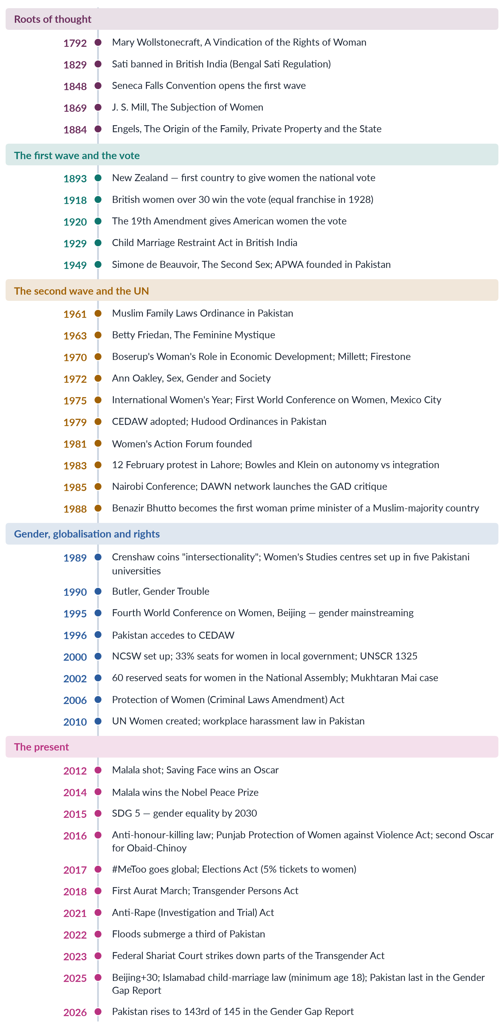
Figure 4 · The timeline behind the paper: the dates that recur across all seven topics.

0.8 Six habits of mind for a Gender Studies paper
1. Define before you discuss. Every good answer opens by defining its key terms — gender, feminism, patriarchy, empowerment — in one clean sentence each. Half the candidates never do, and the examiner notices.
2. Name the theory. Do not write "some people think…". Write "Liberal feminists, from Wollstonecraft to Friedan, argue…". A named theory with a named thinker is worth three vague sentences.
3. Always ask "why?" Gender Studies is about causes. If you describe a problem — low literacy, honour killing, few women in parliament — go on to explain why it exists, using a theory.
4. Bring it home to Pakistan. Every theory has a Pakistani example; every Pakistani fact illustrates a theory. The answer that moves between the two is the answer that scores.
5. Use numbers carefully. One correct, dated statistic from a named source beats five doubtful ones. "Female labour force participation was 24.4% (Labour Force Survey 2024–25)" is evidence; "only 10% of women work" is a guess.
6. Be fair, then be clear. Present the strongest version of the view you disagree with, then give your own reasoned position. That is what a civil servant is paid to do.

0.9 How to handle the sensitive debates
Gender Studies touches questions on which Pakistani society is divided. The examiner is not testing whether you are "for" or "against" feminism. He or she is testing whether you can think clearly and write responsibly about a contested issue. Use this approach on every sensitive question:
BALANCED VIEW · THE FOUR-STEP APPROACH
1. State the issue neutrally, with its facts (what the law says, what happened, what the data shows).
2. Give the main positions fairly — including the strongest argument of each side.
3. Anchor your judgement in the Constitution of Pakistan (equality under Article 25; protection of the family under Article 35; participation of women under Article 34; Islamic provisions under Articles 2A, 31 and 227), in Pakistan's international commitments (CEDAW, the SDGs), and in evidence.
4. Conclude with a practical, dignified way forward that a government could actually adopt.
➜ This is the voice of a civil servant, not an activist or a preacher — and it is the voice that scores.

Table 5 · The sensitive debates you will meet, and where.
Debate | Why it is sensitive | Topic
Religion and women's rights | Some see Islam as the source of women's rights; others see certain interpretations as obstacles. Muslim feminists argue for re-reading the sources. | T2, T3, T5
The transgender law of 2018 | Supporters see a human-rights law; critics object to self-perceived gender identity. The Federal Shariat Court ruled in 2023; an appeal was pending in 2026. | T1, T5
The Aurat March | Supporters see a democratic protest; critics object to some slogans as offensive to local values. | T3
"Western" versus local feminism | Critics call feminism a foreign import; historians show a long local tradition of women's activism. | T2, T3
NGO-isation and foreign funding | Donor money built capacity but, critics argue, depoliticised the movement. | T3, T4
Quotas | Supporters see a fast track to equality; critics see tokenism and dynastic politics. | T6

TRAP · NEVER DO THESE
• Never mock a religious view or a religious scholar. Never mock feminists either.
• Never generalise about "all men" or "all women", or about any province, ethnicity or sect.
• Never quote a Quranic verse or hadith you are not sure of. If you use the Islamic perspective, keep it accurate, brief and respectful.
• Never present an allegation as a fact. Say "critics argue…" or "the court held…".

Part One — The Paper Itself

1.1 Where Gender Studies sits in CSS
The CSS Main Examination carries 1,200 marks: six compulsory papers (600 marks) and optional papers worth another 600 marks, chosen from seven groups. Gender Studies is subject code 31 in Group V, where a candidate chooses one subject of 100 marks from seven: Gender Studies, Environmental Sciences, Agriculture and Forestry, Botany, Zoology, English Literature and Urdu Literature.
Table 6 · Gender Studies in the CSS scheme.
Item | The facts
Paper | Gender Studies — one paper of 100 marks (Group V, code 31)
Structure | Part I: 20 MCQs (20 marks). Part II: seven questions, attempt any four (80 marks)
Time | Three hours in all: Part I has a maximum of 30 minutes; Part II has the remaining two and a half hours
Pass mark | 33 marks in an optional paper (and 50% aggregate in the written examination overall)
First set | CE-2016 — the subject entered the revised scheme "for CE-2016 and onwards"; there was no Gender Studies paper in CE-2015
Record in this set | Eleven papers, CE-2016 to CE-2026; MCQ sheets recovered for seven years

Why candidates choose it, and why it rewards them:
- The syllabus is short and self-contained. Nine heads, most of them with four to seven lines. A disciplined candidate can cover it thoroughly in three to four months alongside other papers.
- It feeds the compulsory papers. Gender is one of the most common themes in the English Essay paper ("Women's empowerment is the key to Pakistan's development"; "Gender equality — myth or reality?"). It overlaps with Current Affairs (the SDGs, climate, the Global Gender Gap), Pakistan Affairs (the Constitution, social problems) and Governance.
- It overlaps with other optional subjects — Sociology, Governance and Public Policies, Criminology, Psychology — so notes serve twice.
- It rewards method. Because most candidates write general, opinion-based answers, a candidate who defines terms, names theories, cites data and law, draws a diagram and applies it all to Pakistan stands out at once.
EXAMINER'S EYE · THE PAPER EVERYONE THINKS IS "GENERAL KNOWLEDGE"
Because gender is discussed on television every day, many candidates assume they can write the paper from common sense. The examiner therefore reads hundreds of answers that say "women are the backbone of society" and little else. The candidate who writes "Liberal feminists such as Betty Friedan argue… but socialist feminists such as Heidi Hartmann reply…", and then gives the Labour Force Survey figure, is in a different league. That gap is the whole strategy of these notes.

1.2 The syllabus, word for word
This is the syllabus exactly as FPSC prints it ("for CE-2016 and onwards"), with the topic of these notes in which each head is taught. Two names are misspelt in the official syllabus — "Mallala Yousaf Zai" and "Shermin Ubaid Chinoy". Always write them correctly: Malala Yousafzai and Sharmeen Obaid-Chinoy.
Table 7 · The official syllabus and where each head is taught.
Head | Syllabus lines | Topic
I. Introduction to Gender Studies | Introduction to Gender Studies · Difference between Gender and Women Studies · Multi-disciplinary nature of Gender Studies · Autonomy vs. Integration Debate in Gender Studies · Status of Gender Studies in Pakistan | T1
II. Social Construction of Gender | Historicizing Constructionism · Problematizing the category of "Sex": Queer Theory · Is "Sex" socially determined, too? · Masculinities and Femininity · Nature versus Culture: A Debate in Gender Development | T1
III. Feminist Theories and Practice | What is Feminism · Liberal Feminism · Radical Feminism · Marxist/Socialist Feminism · Psychoanalytical Feminism · Men's Feminism · Postmodern Feminism | T2
IV. Feminist Movements | Feminist Movements in the West: First Wave, Second Wave and Third Wave Feminism · United Nation Conferences on Women · Feminist Movements in Pakistan | T3
V. Gender and Development | Colonial and Capitalistic Perspectives of Gender · Gender Analysis of Development Theories: Modernization Theory, World System Theory, Dependency Theory, Structural Functionalism · Gender Approaches to Development: WID, WAD, GAD; Gender Critique of Structural Adjustment Policies (SAPs) · Globalization and Gender | T4
VI. Status of Women in Pakistan | Status of Women's health in Pakistan · Status of Women in Education · Women and Employment · Women and Law | T5
VII. Gender and Governance | Defining Governance · Suffragist Movement · Gender Issues in Women as Voters · Gender Issues in Women as Candidates · Gender Issues in Women as Representatives · Impact of Political Quota in Pakistan | T6
VIII. Gender Based Violence | Defining Gender Based Violence · Theories of Violence against Women · Structural and Direct Forms of Violence · Strategies to Eliminate Violence against Women | T7
IX. Case Studies of | Mukhtaran Mai · Malala Yousafzai · Sharmeen Obaid-Chinoy | T7

Four things about this syllabus matter for your preparation:
1. It is older than the paper it produces. Written in the mid-2010s, it says nothing about intersectionality, climate change, digital gender gaps or the fourth wave. The examiner of 2024–2026 asks about all of them. These notes therefore teach every syllabus line and the contemporary layer the examiner has added.
2. Some lines are single words that hide whole debates. "Women and Law" covers the Constitution, family law, criminal law, the Hudood Ordinances, the protective laws of 2004–2025, inheritance and property. "Men's Feminism" covers pro-feminist men, masculinity studies and the HeForShe campaign.
3. Head IV says "First, Second and Third Wave". The fourth wave is not named, but the examiner has asked about "the different waves" (2025) and "digital activism" (2026), so it is taught too.
4. Head IX is three people. Each case study is a doorway into a larger theme: Mukhtaran Mai into jirga justice and rape law; Malala into education, militancy and global advocacy; Sharmeen Obaid-Chinoy into acid violence, honour killing and the power of media to change law.

1.3 The reading list — which books actually help
FPSC lists twenty suggested readings. Some are standard textbooks; some are articles or reports that are hard to find. The table tells you honestly what each gives you. You do not need to read them cover to cover — the Knowledge Bases distil them — but knowing their names and arguments is itself evidence in an answer.
Table 8 · The official reading list, rated.
Title | Author(s) | What it gives you | Use
Theories of Women's Studies | Gloria Bowles and Renate Duelli Klein (eds., 1983) | The founding collection; the introduction frames the autonomy versus integration debate | T1 ★
"Introduction: Theories of Women's Studies and the Autonomy/Integration Debate" | Bowles and Klein | The exact text of the debate the examiner has asked four times | T1 ★
"The State of the Discipline of Women's Studies in Pakistan" (in Social Sciences in Pakistan) | Rubina Saigol | The history and problems of the field in Pakistan | T1
"The State of Women's Studies in Pakistan" (Journal of Asian Women's Studies) | Farzana Bari | The centres of 1989, their achievements and weaknesses | T1
Women's Law in Legal Education and Practice in Pakistan | Farida Shaheed and Rubya Mehdi (eds., 1997) | Women and the legal system; family and criminal law | T5
Locating the Self: Perspectives on Women and Multiple Identities | Nighat Said Khan et al. (eds., 1998) | Identity, religion, ethnicity and class in women's lives — early intersectionality | T1, T2
The Social Construction of Gender | Judith Lorber | The classic account of gender as a social institution | T1 ★
"Queer Theory" (in Gender Inequality) | Judith Lorber | A clear short account of queer theory | T1
Gender (2nd ed., 2013) | Harriet Bradley | A modern textbook on theories of gender | T1, T2
Women of Pakistan: Two Steps Forward, One Step Back? | Khawar Mumtaz and Farida Shaheed (1987) | The standard history of the women's movement to the Zia era, by two WAF founders | T3 ★
Feminism and its Relevance in South Asia | Kamla Bhasin and Nighat Said Khan | What feminism means in South Asia; answers the "Western import" charge | T2, T3
Feminist Thought | Rosemarie Tong | The best single guide to the schools of feminism | T2 ★
Reversed Realities: Gender Hierarchies in Development Thought | Naila Kabeer (1994) | WID/WAD/GAD, empowerment, the household | T4 ★
Gender Planning and Development | Caroline Moser (1993) | Practical and strategic gender needs; the triple role; gender planning | T4 ★
Electoral Politics: Making Quotas Work for Women | Homa Hoodfar and Mona Tajali (2011) | Quotas in Muslim-majority countries, including Pakistan | T6 ★
The Gender Face of Asian Politics | Aazar Ayaz and Andrea Fleschenberg (eds., 2009) | Women politicians in Asia, dynasties and quotas | T6
Performance Assessment of Women Parliamentarians in Pakistan | Farzana Bari (2002) | How women legislators performed after the quota | T6
Baseline Report: Women's Participation in Political and Public Life | Shahla Zia and Farzana Bari (1999) | The situation before the 2002 quota | T6
Freedom from Violence: Women's Strategies from Around the World | Margaret Schuler (ed., 1992) | Strategies to end violence against women | T7
State of Human Rights (annual report) | Human Rights Commission of Pakistan | Yearly data on violence, honour killing, law and justice | T5, T7 ★

Beyond the list — the sources these notes also draw on
The examiner rewards up-to-date evidence. The notes therefore draw on these regularly updated sources, and the Fact Book records the latest figure from each:
- World Economic Forum, Global Gender Gap Report (annual; 2026 edition) — asked by name in 2026.
- Pakistan Bureau of Statistics — Census 2023; Labour Force Survey 2024–25; PSLM surveys.
- National Institute of Population Studies — Pakistan Demographic and Health Survey; Pakistan Maternal Mortality Survey (2019).
- Election Commission of Pakistan — electoral rolls by gender; election results.
- National Commission on the Status of Women (NCSW); the provincial women's commissions.
- UN Women, UNDP (Human Development Report; Gender Inequality Index), WHO, UNICEF, UNFPA.
- GSMA, Mobile Gender Gap Report — the source of the digital-gap figures asked in 2026.
- Human Rights Commission of Pakistan; Sustainable Social Development Organisation; Digital Rights Foundation — data on violence and online harassment.

1.4 How the paper is built
Every Gender Studies paper since 2016 has had the same shape. Knowing it in advance removes surprise on the day.
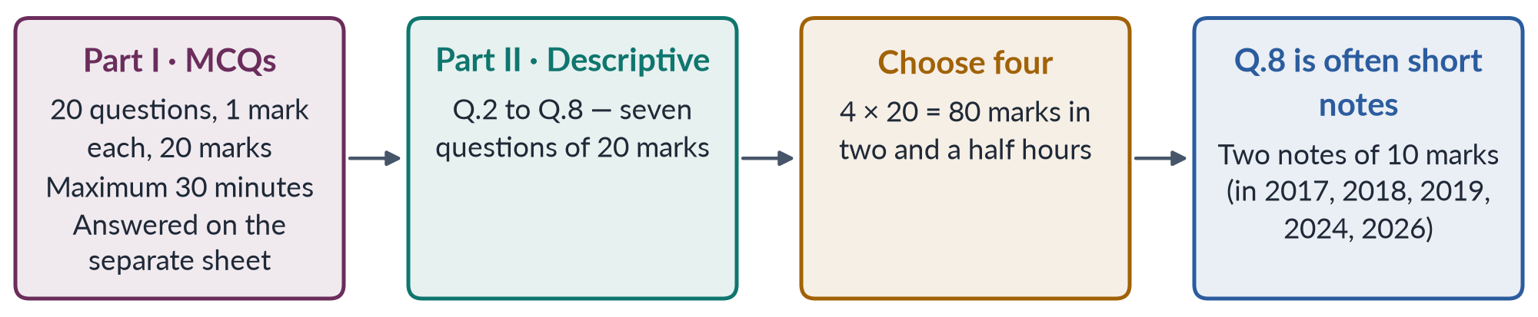
Figure 5 · The shape of the paper: two parts, one answer book for Part II.

Part I — the objective questions (MCQs)
Twenty multiple-choice questions, each with four options, one mark each. They test names (who wrote The Second Sex?), dates (when did Pakistan accede to CEDAW?), terms (what is androgyny?), laws (when was the workplace harassment law passed?) and, increasingly, concepts (what does Butler mean by performativity?). Part Three shows that the MCQ paper has moved sharply from Pakistan facts towards feminist theory since 2023.
TRAP · THE DEFECTIVE MCQ
Several recovered MCQs have no fully correct option, or a published key that is doubtful (for example CSS 2025 Q3 and Q14; several 2026 items whose correct answer was "None of these"). Do not panic when no option looks perfect. Choose the best answer, move on, and do not waste minutes arguing with the paper.

Part II — the descriptive questions
Seven questions numbered 2 to 8 (Question 1 is the MCQ part). Attempt any four; all carry equal marks. The questions come in a small number of shapes, analysed in §3.9: the definition-and-difference question, the explain-a-theory question, the critically-evaluate question, the Pakistan-applied question, the case-study question and the short notes. Since 2024 a new shape has appeared: the long, loaded question that names a report, a law or a statistic and asks you to apply a theory to it (for example 2026 Q2, Q4 and Q5).

The 2015 exception
The past-paper archive in this folder includes a 2015 page for completeness. Gender Studies first appears in the revised scheme "for CE-2016 and onwards", so there was no CE-2015 paper. The record in these notes therefore runs from 2016 to 2026: eleven papers.

1.5 The marks and the minutes
Three hours pass quickly. Plan them before the day, and keep to the plan.
Table 9 · A working time plan for the three hours.
Stage | Minutes | What you do
Part I (MCQs) | 20–25 | Answer all twenty. Mark doubtful ones, return to them, never leave a blank. Hand in the sheet on time.
Choosing | 8–10 | Read all seven questions twice. Tick the four you can answer best — prefer questions where you have theory and Pakistan evidence. Note the command words.
Answer maps | 4 × 3 | For each chosen question, draw a quick map in the margin or on the rough sheet: introduction, numbered headings, evidence for each, diagram, conclusion.
Writing | 4 × 30 | About 30 minutes per answer: roughly six to eight handwritten pages (about 1,000–1,300 words).
Review | 5–8 | Underline key terms, check numbers and names, number your headings clearly.

How are the 20 marks of a descriptive answer earned? FPSC does not publish a marking scheme. The table below is a practical guide built from what examiners' reports and experienced markers say they reward. Use it to check your practice answers.
Table 10 · Where the 20 marks come from (a working guide, not an official scheme).
Element | Marks | What earns them
Introduction | 2 | Definitions of the key terms; context; a one-sentence thesis that answers the question.
Structure | 3 | Numbered headings taken from the question's words; logical order; every limb of the question answered.
Content | 8 | Correct, relevant knowledge: theories, arguments, history, analysis.
Evidence | 4 | Named thinkers, dated data from named sources, laws, reports and cases — inside the points.
Critical and Pakistan angle | 2 | Counter-arguments, evaluation, application to Pakistan.
Conclusion | 1 | A judgement and a way forward, not a repetition.

1.6 Why candidates fail — and how to be in the other group
Candidates rarely fail Gender Studies because they know nothing. They fail, or score in the thirties and low forties, for predictable reasons:
1. Opinion instead of analysis. "Women are oppressed in our society due to illiteracy and male dominance" repeated for six pages. The cure: name theories and thinkers, and explain causes.
2. No definitions. Writing about "feminism" or "gender mainstreaming" without ever saying what it means. The cure: define every key term in your introduction.
3. Answering the topic, not the question. Asked to "evaluate the impact of the quota", the candidate writes the history of women in politics. The cure: take your headings from the question's own words (Part Five).
4. One limb only. Many questions have two or three parts ("Differentiate… and discuss…"). Half-answered questions cap at half marks. The cure: the answer map, which puts each limb on the page before you write.
5. Western theory with no Pakistan. Or Pakistani complaints with no theory. The cure: every heading links the two.
6. Doubtful facts. "Pakistan is the worst country for women" (it is not a ranking any report makes in those words), "50% of women are illiterate" (out of date). The cure: the Fact Book, with sources and years.
7. Shouting. Attacks on the West, on religion, on men or on feminists. The cure: the balanced view (§0.9).
8. Poor time control. A brilliant first answer and a half-page fourth. The cure: the time plan above, practised on the Prediction Papers.

1.7 The eleven papers at a glance
The table shows where every question of every paper came from, using the seven topics of these notes (explained in Part Two). Read along a row to see the balance of a single paper; read down the columns and you will see that no topic is ever safe to skip.
Table 11 · The eleven papers at a glance: which topic each question came from (a slash = a short-note question split between topics).
Year | Q2 | Q3 | Q4 | Q5 | Q6 | Q7 | Q8
2016 | T1 | T7 | T6 | T3 | T1 | T2 | T4
2017 | T1 | T7 | T6 | T5 | T4 | T1 | T7/T4
2018 | T1 | T1 | T2 | T5 | T4 | T6 | T4/T3/T7
2019 | T1 | T3 | T4 | T4 | T5 | T7 | T6/T2/T4
2020 | T1 | T4 | T1 | T6 | T5 | T7 | T7
2021 | T1 | T1 | T2 | T2 | T4 | T4 | T6
2022 | T1 | T2 | T3 | T6 | T3 | T4 | T4
2023 | T1 | T1 | T1 | T3 | T4 | T5 | T7
2024 | T5 | T4 | T3 | T4 | T7 | T6 | T1/T2
2025 | T7 | T4 | T3 | T6 | T2 | T4 | T7
2026 | T1 | T3 | T5 | T4 | T3 | T5 | T5/T7

Three patterns are visible at once:
- Almost every paper visits five topics or more. Three papers (2018, 2019, 2024) touched all seven; only 2021 visited as few as four. A candidate who skips two topics risks finding only three answerable questions. Selective study is dangerous.
- T1 (the discipline and social construction) dominated the early papers — two questions in most years from 2016 to 2021, and three in 2023 — but then almost vanished: one question in 2024 (a short note), none in 2025, one in 2026. Its questions have become sharper and more theoretical (queer theory and the transgender law in 2026).
- T4 (gender and development) is present in every single paper from 2016 to 2026. It is the one topic you can be sure of meeting.

Part Two — Seven Topics: Rebuilding the Syllabus

2.1 Why seven topics — and why these seven
The nine syllabus heads are uneven. Head I (the discipline) and Head II (social construction) are both short and conceptual, and the examiner mixes them freely: the question "how do you deconstruct the word gender?" (2020) belongs to both. Head IX is not a subject at all but three people, all of whose stories are stories of violence and resistance. Meanwhile Head V (gender and development) is the heaviest head in the record and needs a long topic of its own.
A good topic is one unit you can master in two to three weeks, whose questions are answered in one recognisable way. Two decisions follow, and nothing else is moved:
1. Heads I and II become Topic 1. You cannot explain the discipline of Gender Studies without the idea of gender as a social construction, and you cannot discuss social construction without the discipline that invented it. Together they form the foundation of the subject — "what is gender, and how do we study it?" — and the examiner treats them as one family.
2. Heads VIII and IX become Topic 7. Mukhtaran Mai (rape ordered by a village council), Malala Yousafzai (shot for demanding education) and Sharmeen Obaid-Chinoy (films on acid attacks and honour killing) are each a case study of violence against women and the resistance to it. Studying them inside the violence topic means every case study answer arrives with theory, law and data already in hand — and every violence answer can call on a vivid case.
Heads III, IV, V, VI and VII each become one topic, unchanged. No syllabus line is split between topics, and no line is dropped.
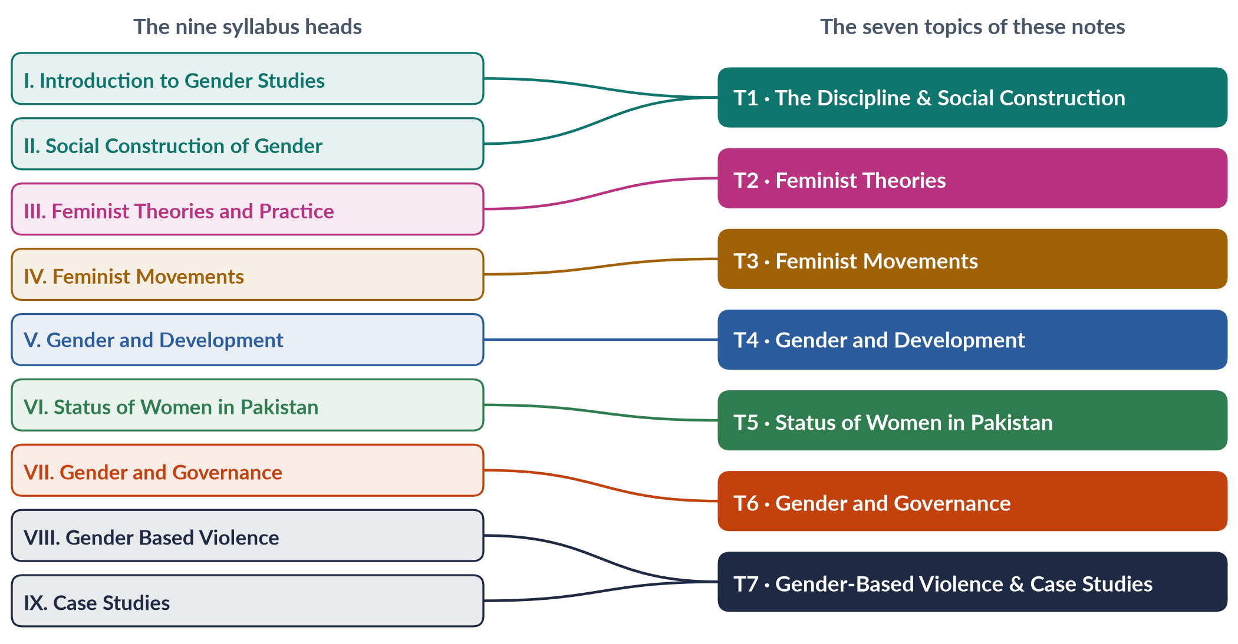
Figure 6 · From nine syllabus heads to seven topics: nothing is dropped, nothing is split.

2.2 The seven topics at a glance
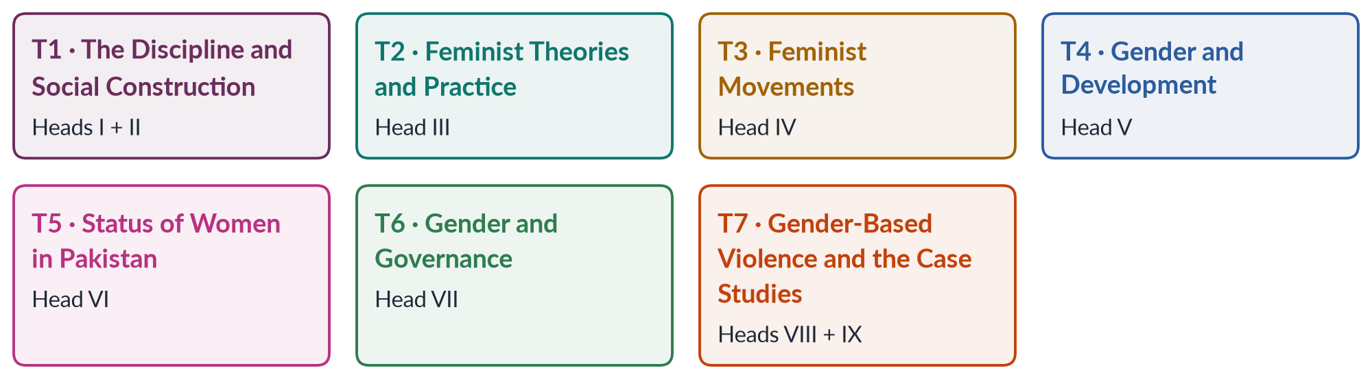
Figure 7 · The seven topics of these notes, with the syllabus heads each one carries.
Table 12 · The seven topics.
T | Topic | Heads | What it covers
T1 | Gender Studies and the Social Construction of Gender | I + II | The meaning and birth of the discipline; Women's vs Gender Studies; its multidisciplinary nature; autonomy vs integration; the field in Pakistan; sex and gender; the history of constructionism; queer theory; is sex also constructed?; masculinities and femininities; nature vs culture; gendered language; the transgender debate.
T2 | Feminist Theories and Practice | III | What feminism is; liberal, radical, Marxist/socialist, psychoanalytic, men's and postmodern feminism; plus intersectionality, Black, postcolonial, eco- and Muslim feminisms; which feminism suits Pakistan.
T3 | Feminist Movements — the West, the UN and Pakistan | IV | The four waves in the West; the suffrage struggle; the UN conferences, CEDAW and Beijing; the women's movement in Pakistan from APWA to WAF to Aurat March; NGO-isation; digital activism.
T4 | Gender and Development | V | Colonial and capitalist perspectives; modernisation, dependency, world-system and structural functionalism; WID, WAD, GAD; Moser and Kabeer; SAPs; globalisation; gender and climate change.
T5 | Status of Women in Pakistan | VI | Health, education, employment and law; the Constitution and pro-women laws; the Global Gender Gap; intersectional disadvantage; the digital divide; climate impacts on women.
T6 | Gender and Governance | VII | Defining governance; the suffragist movement; women as voters, candidates and representatives; the history and impact of quotas; women in leadership.
T7 | Gender-Based Violence and the Three Case Studies | VIII + IX | Defining GBV; theories; structural and direct forms; laws and strategies; masculinities and violence; Mukhtaran Mai, Malala Yousafzai, Sharmeen Obaid-Chinoy.

2.3 What each topic adds beyond the syllabus's words
The syllabus names the minimum. The examiner has repeatedly asked beyond it (§3.7). Each topic therefore carries the syllabus lines and the additions the record demands.
Table 13 · The additions each topic carries, and why.
T | Added beyond the syllabus words | Why
T1 | Gendered language; the transgender law (2018) and the Federal Shariat Court judgment (2023); androgyny; "doing gender"; the history of Women's Studies centres in Pakistan | Asked in 2020 (language) and 2026 (transgender law); frequent in MCQs
T2 | Intersectionality; Black, postcolonial, eco- and Muslim feminism; standpoint theory; patriarchal bargain; kyriarchy; matrix of domination; "which feminism for Pakistan" | Intersectionality asked in 2025 and 2026; the 2023–2026 MCQs are full of these names
T3 | The fourth wave and #MeToo; Beijing+30 (2025); CEDAW reporting; NGO-isation; digital activism; the local roots of South Asian feminism | Asked in 2025 ("different waves"), 2026 (digital activism; NGO-isation)
T4 | Moser's practical and strategic needs; Kabeer's empowerment; gender mainstreaming; the MDGs and SDGs; ecofeminism and climate; "development as coloniality"; gender budgeting | Asked in 2018 (needs), 2024 (coloniality), 2026 (climate)
T5 | The Global Gender Gap Report; the Gender Inequality Index; the digital gender gap; intersectional disadvantage; climate impacts; the child-marriage laws of 2025–2026 | Asked in 2018 and 2026 (gap report), 2026 (digital gap; intersectionality)
T6 | Women in leadership; the Elections Act 2017; reserved seats in the 2024 elections; critical mass; violence against women in politics | Asked in 2020 (leadership), 2024 (political participation as a human right)
T7 | Masculinity studies and violence; online violence; the Islamabad Domestic Violence Act (2025); the root-causes (ecological) model | Asked in 2025 (root causes) and 2026 (masculinity studies)

2.4 The contemporary layer — the hot topics each topic carries
The examiner of 2024–2026 wants the subject applied to the present. Every Knowledge Base therefore ends its teaching with a chapter of contemporary debates, and the Prediction Papers draw heavily on them. This is the list the notes will cover.
Table 14 · The contemporary layer, topic by topic.
T | Contemporary debates the notes will cover
T1 | The transgender law and the courts; "gender ideology" debates worldwide; the growth and funding of Gender Studies departments in Pakistan; masculinity in crisis; gender in textbooks (the Single National Curriculum debate); social media and gender norms
T2 | Is feminism a "Western import"?; Muslim feminism and re-reading the sources; intersectionality in Pakistan; ecofeminism and climate justice; the backlash against feminism online; men as allies
T3 | The Aurat March and its slogans; the fourth wave and #MeToo in Pakistan; Beijing+30 (2025) and the review of progress; NGO-isation and donor dependence; digital activism and its risks; the anti-gender backlash worldwide
T4 | Gender and climate change (the 2022 floods, heat waves); the care economy and unpaid work; gender budgeting; the SDGs at mid-point; IMF programmes and austerity; platform and gig work; artificial intelligence and women's jobs
T5 | The Global Gender Gap 2025–2026; female labour-force participation; out-of-school girls; maternal and mental health; the digital gender gap; child-marriage laws (2025–2026); inheritance in practice; intersectional disadvantage of minority, rural and disabled women
T6 | Women in the 2024 elections; the 10% turnout rule and missing women voters; dynastic politics; women ministers; violence against women in politics; the 33% representation on public boards (2026 bills)
T7 | Domestic violence laws (Islamabad 2025); online abuse and PECA; honour killings in the HRCP data; femicide; jirga "justice"; masculinity and violence; Mukhtaran Mai, Malala and Obaid-Chinoy today

2.5 The two documents each topic gets

The Knowledge Base (TnKB)
Each Knowledge Base has a teaching core of 15,000 to 19,000 words, longer for the heavier topics, followed by its one-liner bank and revision sheet (together about 6,000 more words). It is written for a beginner and builds the topic from zero:
1. How to use this document, and the contents.
2. Part Zero — the ABC of the topic. The key terms, each defined in one sentence with an example; the background you need; a one-page picture of the whole topic.
3. Part One — the chapters. One chapter for every syllabus line and every family of past questions, built from the question words. Headings go up to five levels deep. Every point carries its evidence card inside it. Every chapter has simple-words boxes, examples, traps and at least one diagram — ten to eighteen diagrams per topic.
4. Part Two — contemporary debates. The live controversies of the topic (§2.4), each with a balanced view and the latest data.
5. Part Three — the examiner's record of the topic. Every past question, what the record reveals, and five likely questions for the next paper (not solved here; the Prediction Papers solve predicted questions).
6. Part Four — the one-liner bank. About 120 numbered one-liners written in the style of the past MCQs, with the key words, names and dates in bold, followed by every recovered MCQ on the topic with its key.
7. Part Five — the revision sheet. The whole topic in a few detailed pages for the night before the exam: every term with its meaning, every thinker with their idea, every date with its event — so that it makes complete sense without the chapters. The same sheet forms the topic's chapter of the Revision Notes volume.

The Question Answers (TnQA)
Each Question Answers document answers every past question of its topic as a model of 1,000–1,300 words — the length a strong candidate can actually write in thirty minutes. Each answer has five parts:
1. The question exactly as set, with its year and number.
2. The answer map — a mind map whose centre states what the question asks, part by part; every branch is one numbered heading, and every point is a short phrase that makes complete sense on its own.
3. Decoding the question — what the command words demand and what each limb requires.
4. The model answer — main headings 1, 2, 3… from the question's own words, each with sub-headings i), ii), iii)… answered in short paragraphs with the key words in bold; an introduction with a simple definition, background, Pakistani context and argument; evidence inside every heading; at least one figure besides the answer map; the Pakistan angle; a balanced conclusion.
5. Why this answer scores — what the examiner rewards in it.
Where two questions are exact repeats (2019 Q3 and 2023 Q5), one full answer is given and the repeat is marked. Where questions are near repeats with different limbs, each gets its own answer, because the limbs change the structure. Short notes get complete answers of about 550–650 words each.
Table 15 · Planned length of each topic's documents, weighted by the record.
T | Topic | Visits | KB words | QA answers | Rank
T1 | Gender Studies and the Social Construction of Gender | 16.5 | about 18,500 | 16 full + 1 note | 2
T2 | Feminist Theories and Practice | 7 | about 17,500 | 6 full + 2 notes | 7
T3 | Feminist Movements | 9.5 | about 17,000 | 9 full + 1 note | 4
T4 | Gender and Development | 17.5 | about 19,000 | 16 full + 3 notes | 1
T5 | Status of Women in Pakistan | 8.5 | about 17,000 | 8 full + 1 note | 5
T6 | Gender and Governance | 8.5 | about 16,000 | 8 full + 1 note | 5
T7 | Gender-Based Violence and the Case Studies | 10.5 | about 18,000 | 9 full + 3 notes | 3

T2 has the fewest visits but a long Knowledge Base, because it carries the most MCQs of any topic after T1 (26 of 140), because its theories are used inside every other topic, and because the examiner's new favourite — intersectionality — lives there.

2.6 The compiled volumes
When all seven topics are complete, five volumes are compiled from them (Figure 1):
- The Fact Book (FB) records every fact in the set — dates, numbers, statistics with source and year, laws with their key sections, conventions, conferences, reports, thinkers and their books, cases and people — arranged topic by topic and then by type. It is different from an ordinary summary: it is a reference to memorise from and to refresh before the exam. Because data changes, every statistic in it carries its source and year, and it is the one volume updated last.
- The Question Answers (QA) print volume gathers all seven TnQA documents in syllabus order.
- The One-Liner and MCQ Bank (OL) gathers the one-liners of every Knowledge Base, all 140 recovered MCQs with explained keys, and new practice MCQs written on every syllabus line — especially the lines the objective paper has not yet touched.
- The Revision Notes (RN) carry the whole subject for the last three weeks. They are deliberately fuller than a one-page summary: about 4,500 words per topic, with every theory, every argument frame, the essential data and laws, the answer structures for the families that repeat, and the key diagrams redrawn in simple form.
- The Prediction Papers (PR) are three complete papers set exactly as FPSC prints the Gender Studies paper: the FPSC heading, time and marks, the printed instructions, Part I with 20 MCQs (options A–D) and Part II with seven questions (Q.2 to Q.8, attempt four, 20 marks each, with one question of two short notes). Each set is followed by the MCQ key and full model answers. Together they add 21 predicted descriptive questions drawn from the blind spots, the repeat engine and the contemporary layer.

Part Three — The Record: What Has Been Asked, 2016–2026
The examiner has a memory, habits and a direction of travel. This part reads all three from eleven papers, so that you prepare for the paper that is likely, not the paper you fear.

3.1 How the record was built
Every descriptive question from CE-2016 to CE-2026 was taken from the past-paper volume in this folder. That is 77 questions. The five short-note questions (2017, 2018, 2019, 2024, 2026) were split into their parts, because each part is a separate subject: 84 items in all. Each item was then tagged four ways:
1. Topic — which of the seven topics it belongs to (its "home").
2. Family — the underlying question it asks, whatever the wording. "Write a comprehensive note on the autonomy versus integration debate" (2017) and "Discuss in detail how the autonomy and integration debate has contributed to the field" (2021) belong to the same family. There are 48 families.
3. Command words — define, differentiate, discuss, critically evaluate, and so on.
4. Leaks — any second topic the answer needs.
A full question counts as one visit to its topic; a short-note part counts as half a visit. The 140 MCQs recovered for 2016, 2018, 2019 and 2023–2026 were tagged by topic too. (The MCQ sheets for 2017, 2020, 2021 and 2022 could not be reliably recovered; no reconstruction has been attempted.)

3.2 The heat map
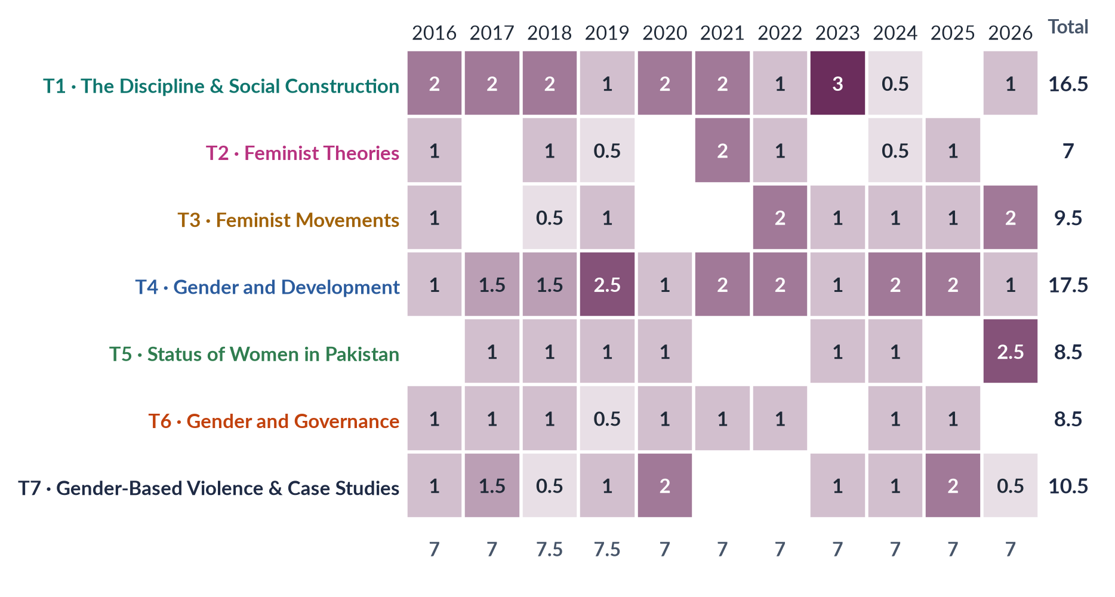
Figure 8 · The heat map: visits to each topic, year by year (a full question = 1, a short-note part = ½).

How to read it
Each row is a topic, each column a paper. The darker the cell, the more the examiner visited that topic that year; the right-hand column is the total over eleven years. Three things stand out:
- Two topics carry the paper. T4 (gender and development, 17.5) and T1 (the discipline and social construction, 16.5) together account for 44% of all visits.
- T4 never misses. It appears in every paper, usually with one or two questions, and in 2019 with two and a half.
- T1 has cooled. After dominating 2016–2023, it fell to half a visit in 2024 and none in 2025. But its 2026 question — queer theory and the transgender law — shows it returning in a harder, contemporary form.
The same record, read by the nine syllabus heads rather than the seven topics, shows where inside each topic the pressure falls:
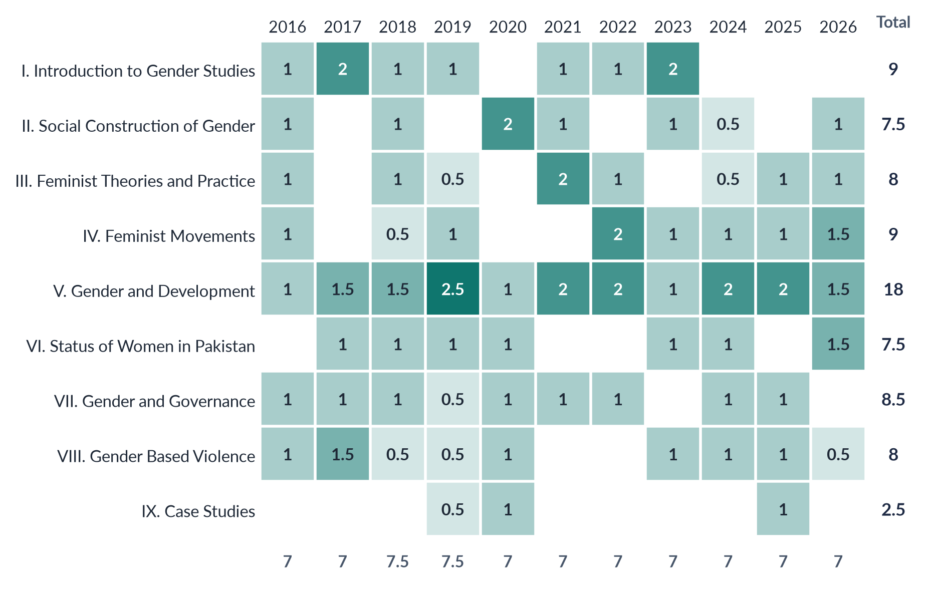
Figure 9 · The same record by the nine syllabus heads (a question touching two heads is shared between them).

3.3 How much each topic weighs
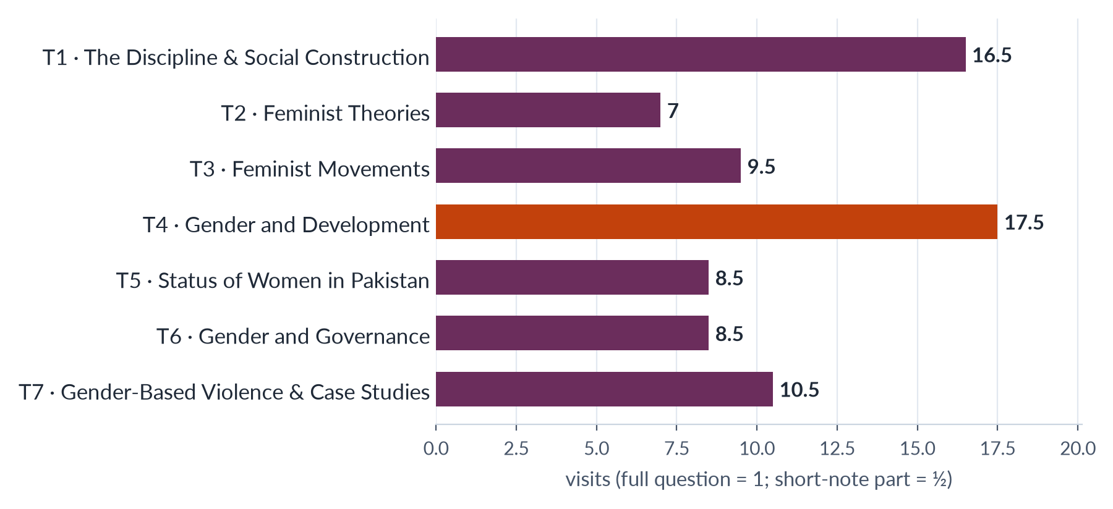
Figure 10 · How much each topic weighs: total visits, 2016–2026 (the heaviest in coral).
The weights are unequal, but the lesson is not "study only the heavy topics". Look at the columns of the heat map: in most years, three or four different topics supply the seven questions. You need four good answers. A candidate who has mastered T1, T4 and T7 and neglected the rest will, in a typical year, find two or three questions they can answer well — not four. Master every topic; master the heavy ones deeply.
Table 16 · The seven topics ranked by weight.
Rank | Topic | Visits | Share | In how many of 11 papers
1 | T4 · Gender and Development | 17.5 | 22% | 11
2 | T1 · The Discipline & Social Construction | 16.5 | 21% | 10
3 | T7 · Gender-Based Violence & Case Studies | 10.5 | 13% | 9
4 | T3 · Feminist Movements | 9.5 | 12% | 8
5= | T5 · Status of Women in Pakistan | 8.5 | 11% | 7
5= | T6 · Gender and Governance | 8.5 | 11% | 9
7 | T2 · Feminist Theories | 7 | 9% | 7

3.4 The repeat engine
The strongest predictor of the next paper is the last ten. The examiner returns again and again to a small number of families. Below, every family is listed by how often it has been asked.

The families asked three times or more
Family | Topic | Times | Years asked
GBV — forms, sites and strategies to eliminate it | T7 | 5 | 2016, 2017, 2019, 2023, 2024
WID, WAD and GAD | T4 | 5 | 2016, 2017, 2021, 2025, 2026
The waves of Western feminism and their influence on Pakistan | T3 | 5 | 2019, 2022, 2023, 2024, 2025
Status of Gender / Women's Studies in Pakistan | T1 | 4 | 2016, 2018, 2019, 2023
The autonomy versus integration debate | T1 | 4 | 2016, 2017, 2021, 2023
Political quotas for women | T6 | 4 | 2016, 2021, 2024, 2025
The women's movement in Pakistan | T3 | 4 | 2016, 2022, 2024, 2026
Women's Studies versus Gender Studies | T1 | 4 | 2017, 2018, 2019, 2023
Globalisation and gender | T4 | 4 | 2017, 2018, 2019, 2025
Sex versus gender; is sex socially constructed; nature versus nurture | T1 | 4 | 2018, 2020, 2021, 2024
Colonial and capitalist perspectives of gender | T4 | 4 | 2020, 2022, 2023, 2024
Social construction of gender — theories; deconstructing 'gender' | T1 | 3 | 2016, 2020, 2026
Women's political participation | T6 | 3 | 2017, 2018, 2024
Women's health in Pakistan | T5 | 3 | 2017, 2023, 2024
Gender analysis of development theories | T4 | 3 | 2019, 2024, 2025

These fifteen families are the core of the paper. Between them they account for 51 of the 84 items — three in every five. Every one of them gets a full model answer in the QA documents, and most get more than one, because each repetition came with a different limb.

The families asked twice
Family | Topic | Times | Years asked
What is feminism; schools of feminism compared | T2 | 2 | 2016, 2022
Radical feminism | T2 | 2 | 2016, 2024
Marxist / socialist feminism | T2 | 2 | 2016, 2021
Gender Studies as a discipline — meaning, need, scope | T1 | 2 | 2017, 2019
Pakistan and the Global Gender Gap | T5 | 2 | 2018, 2026
Women, law and human rights | T5 | 2 | 2018, 2020
GBV — laws and state initiatives | T7 | 2 | 2018, 2024
Modernisation (and dependency) theory | T4 | 2 | 2019, 2021
GBV — causes, theories, power and control | T7 | 2 | 2020, 2025
Masculinities, femininities and gender roles | T1 | 2 | 2021, 2023
The multidisciplinary nature of Gender Studies | T1 | 2 | 2022, 2023
Intersectionality | T2 | 2 | 2025, 2026

The families asked once
Family | Topic | Times | Years asked
Honour killing | T7 | 1 | 2017
Which feminism suits Pakistan | T2 | 1 | 2018
Practical and strategic gender needs | T4 | 1 | 2018
APWA and WAF | T3 | 1 | 2018
Women and paid employment | T5 | 1 | 2019
Case study — Mukhtaran Mai | T7 | 1 | 2019
The suffragist movement | T6 | 1 | 2019
Postmodern feminism | T2 | 1 | 2019
Structural functionalism | T4 | 1 | 2019
Gendered language | T1 | 1 | 2020
Women in leadership | T6 | 1 | 2020
Case study — Sharmeen Obaid-Chinoy | T7 | 1 | 2020
Psychoanalytic feminism | T2 | 1 | 2021
Women as representatives / politicians | T6 | 1 | 2022
Gender critique of Structural Adjustment Policies | T4 | 1 | 2022
Case study — Malala Yousafzai | T7 | 1 | 2025
Queer theory and transgender rights | T1 | 1 | 2026
Gender, climate change and ecofeminism | T4 | 1 | 2026
NGO-isation of the women's movement | T3 | 1 | 2026
The digital gender gap | T5 | 1 | 2026
Masculinities and violence against women | T7 | 1 | 2026

Exact and near repeats
The examiner does not mind repeating himself or herself word for word.
Table 17 · Exact and near repeats in the record.
First asked | Asked again | How close
2019 Q3 | 2023 Q5 | Identical: "Outline and explain the three major waves of feminist movements in the West. Discuss the influence of these waves on feminist movements in Pakistan."
2016 Q2 | 2023 Q2 | Near identical: a note on the status of Women's/Gender Studies in Pakistan, plus views on the autonomy vs integration debate.
2016 Q8 | 2021 Q7 | Near identical: critically review / analyse WID, WAD and GAD. (Asked again with two of the three in 2025 Q7.)
2016 Q3 | 2017 Q3; 2023 Q8 | Same family: the forms of violence against women in Pakistan and strategies to eliminate it.
2022 Q7 | 2023 Q6; 2024 Q3 | Same family: the colonial and capitalist perspectives of gender (2024 adds "development as coloniality").
2017 Q6 | 2018 Q6; 2019 Q5; 2025 Q3 | Same family: globalisation and gender inequality (2025 adds world-system theory).
2022 Q2 | 2023 Q3 | Same limb: the multidisciplinary nature of Gender Studies.
2019 Q4 | 2021 Q6 | Same family: modernisation theory and women's subordination.

EXAMINER'S EYE · WHAT REPETITION MEANS FOR YOU
The examiner is not short of ideas; he or she is testing the core. A family asked four or five times will be asked again. The question is never whether the waves, WID/WAD/GAD, the forms of violence, the women's movement or the quota will appear — only in what form. That is why the QA documents answer every repetition separately: the new limb (influence on Pakistan; "compare past and emerging trends"; "development as coloniality") is where the marks are.

3.5 The leaks between topics
Many questions have a home topic but need material from another. The table lists every leak in the record. The Knowledge Bases cross-reference each other at exactly these points, so that no answer is ever built from one topic alone.
Table 18 · The leaks: questions that draw on two topics.
Question | Home topic | Also needs | Why
CSS 2017 · Q4 | T6 | T5 | democracy and development need the status data of T5
CSS 2018 · Q4 | T2 | T3 | choosing a feminism for Pakistan needs the movement's history (T3)
CSS 2018 · Q5 | T5 | T3 | reasons for the ranking include the history of laws and the movement (T3)
CSS 2018 · Q6 | T4 | T5 | impacts of globalisation on Pakistani women need T5 data
CSS 2018 · Q8(c) | T7 | T5 | government initiatives sit with the laws of T5
CSS 2019 · Q8(a) | T6 | T3 | the suffragists are also the first wave (T3)
CSS 2020 · Q3 | T4 | T3 | colonial reformers are also the roots of the movement (T3)
CSS 2024 · Q6 | T7 | T5 | the 2016 Punjab Act is also women and law (T5)
CSS 2025 · Q6 | T2 | T1 | intersectionality begins with the question 'what is gender?' (T1)
CSS 2025 · Q8 | T7 | T5 | Malala is also the story of girls' education (T5)
CSS 2026 · Q2 | T1 | T5 | the transgender law is also women and law (T5)
CSS 2026 · Q4 | T5 | T6 | the gap report's political empowerment sub-index is T6
CSS 2026 · Q5 | T4 | T2, T5 | ecofeminism is a theory (T2); flood impacts are status data (T5)
CSS 2026 · Q6 | T3 | T4 | the WAD critique is taught in T4
CSS 2026 · Q7 | T5 | T2 | intersectionality as a theory is taught in T2
CSS 2026 · Q8(b) | T7 | T1 | masculinities are first taught in T1

The strongest channels are T5 ↔ everything (Pakistan's data and laws feed almost every applied question), T2 ↔ T1 and T5 (intersectionality), and T3 ↔ T4 (the NGO-isation debate joins the movement to development).

3.6 The blind spots — syllabus lines never asked, 2016–2026
Some syllabus lines have never been the subject of a descriptive question. Blind spots are dangerous in two ways: candidates skip them, and examiners eventually fill them. The last three papers broke several long silences (world-system theory by name in 2025; queer theory in 2026), so expect more.
Table 19 · The blind spots of the descriptive paper.
Head | Syllabus line | Record
II | Historicizing Constructionism | Never by name (2016 Q6 asked for "theories of social construction")
III | Liberal Feminism | Never on its own; only inside comparisons (2022 Q3 "two Western schools"). MCQ 2023
III | Men's Feminism | Never asked, in either part of the paper
III | Psychoanalytic / Postmodern | Once each (2021 Q5; 2019 note)
IV | United Nations Conferences on Women | Never a descriptive question — though a favourite of the MCQs (2016, 2019, 2023, 2024, 2026)
IV | Third Wave on its own | Only paired with the first wave (2022) or within "the three waves"
V | World-System and Dependency theories | Only as partners of other theories (2019, 2025)
VI | Status of Women in Education | Never a full question — only through Malala (2025) and intersectionality (2026)
VI | Women and Law | Once directly (2020 Q6, human-rights quotation); partly in 2018 Q5
VII | Defining Governance | Never asked
VII | Gender Issues in Women as Voters | Never asked on its own
VII | Women as Candidates | Only within "obstacles faced by women politicians" (2024 Q7)

EXAMINER'S EYE · THE MOST LIKELY BLIND SPOTS TO BREAK
Three blind spots stand out: women and education (a whole syllabus line, never asked, and at the centre of national debate — 25 million or more children out of school, most of them girls); the UN conferences on women (Beijing+30 in 2025 gives the examiner a perfect hook); and women as voters (the gender gap in the electoral rolls and the 10% turnout rule are rich, current material). Each is taught in full depth in its topic, and each is a strong candidate for the Prediction Papers.

3.7 Beyond the syllabus — what the examiner asked that the syllabus never names
Table 20 · Beyond the syllabus: questions whose subject the syllabus does not name.
Question | Topic | What it asked that the syllabus never names
CSS 2018 · Q5 | T5 | Pakistan's global gender-gap ranking (the WEF Global Gender Gap Report)
CSS 2018 · Q8(a) | T4 | Caroline Moser's practical and strategic gender needs (on the reading list, not in the syllabus)
CSS 2020 · Q4 | T1 | Gendered language
CSS 2025 · Q6 | T2 | Intersectionality as a theory
CSS 2026 · Q4 | T5 | The Global Gender Gap Report 2025 — a named, dated report
CSS 2026 · Q5 | T4 | Climate change, feminist environmentalism and ecofeminism; the 2022 floods and heat waves
CSS 2026 · Q7 | T5 | Intersectionality applied to rural, minority and disabled women in Pakistan
CSS 2026 · Q8(a) | T5 | The digital gender gap — mobile internet use, 2024–2025

Eight items — 10% of the record — ask about something the syllabus does not name, and six of the eight come from the last two papers. The direction is unmistakable: the examiner reads the news, the reports and the recent literature, and expects you to have done so too. The contemporary layer of every Knowledge Base (§2.4) exists to meet exactly this demand.

3.8 The objective paper, 2016–2026
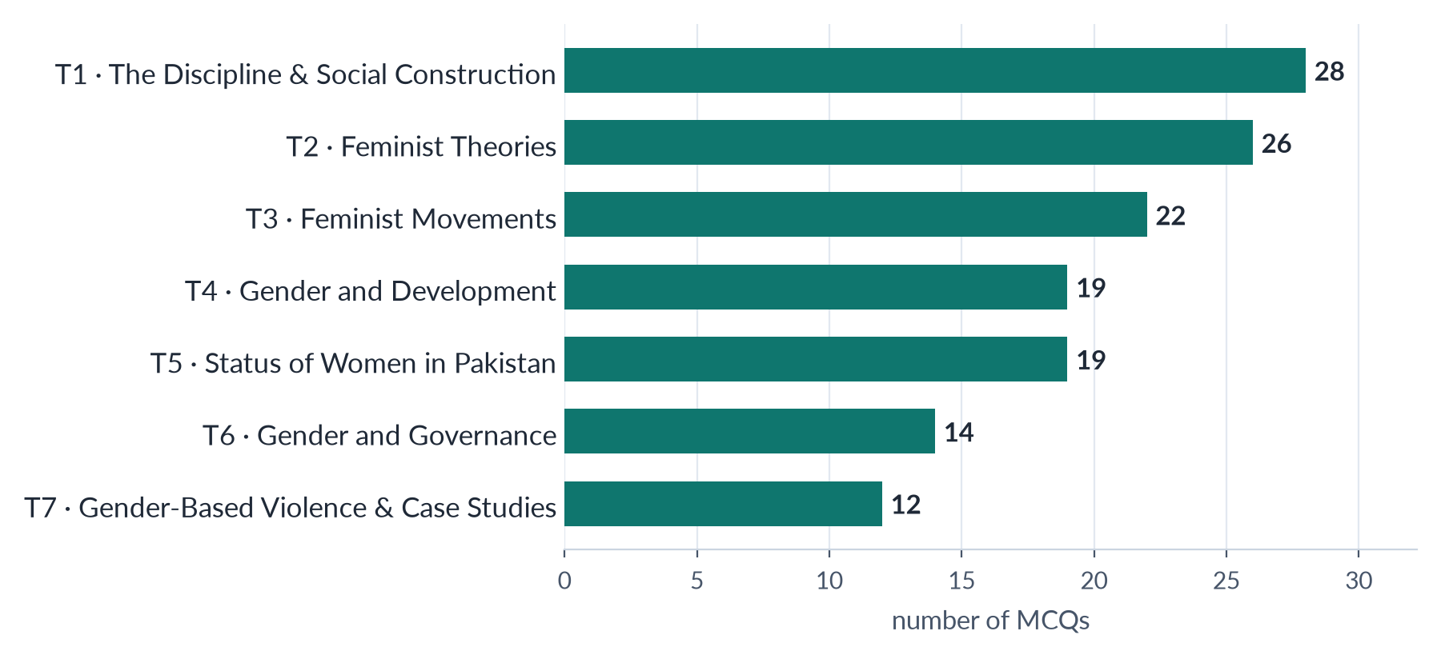
Figure 11 · The objective paper: the 140 recovered MCQs by topic (2016, 2018, 2019, 2023–2026).
Table 21 · The 140 recovered MCQs, topic by year.
Topic | 2016 | 2018 | 2019 | 2023 | 2024 | 2025 | 2026 | Total | Share
T1 · The Discipline & Social Construction | 1 | 6 | 1 | 9 | 4 | 3 | 4 | 28 | 20%
T2 · Feminist Theories | 3 | 1 | 3 | 3 | 4 | 6 | 6 | 26 | 19%
T3 · Feminist Movements | 4 | 3 | 4 | 1 | 2 | 4 | 4 | 22 | 16%
T4 · Gender and Development | – | 3 | 4 | 3 | 2 | 4 | 3 | 19 | 14%
T5 · Status of Women in Pakistan | 5 | 5 | 4 | 1 | 3 | – | 1 | 19 | 14%
T6 · Gender and Governance | 5 | 2 | 2 | – | 3 | 1 | 1 | 14 | 10%
T7 · Gender-Based Violence & Case Studies | 2 | – | 2 | 3 | 2 | 2 | 1 | 12 | 9%
All | 20 | 20 | 20 | 20 | 20 | 20 | 20 | 140 | 100%

What the MCQs teach
- The MCQ paper and the descriptive paper weigh the topics differently. T4 dominates the descriptive paper but supplies only 19 of 140 MCQs. T1 and T2 supply 54 between them — nearly two in five — because the objective paper loves names, books and terms: who coined "hegemonic masculinity", who wrote Gender Trouble, what is androgyny.
- The objective paper has turned theoretical. In 2016, 2018 and 2019 most MCQs asked about Pakistan: laws, dates and "firsts" (the first woman Speaker, the first woman Foreign Secretary). From 2023, most ask about theory: performativity, standpoint theory, strategic essentialism, kyriarchy, the matrix of domination, Foucault's repressive hypothesis. In 2025 and 2026 together, 12 of 40 MCQs came from T2 alone.
- Defective items are common. Several recent items had no correct option ("None of these" was the right answer to six 2026 items). Know the fact well enough to recognise when every option is wrong.

MCQ facts asked more than once
Table 22 · The facts the objective paper keeps returning to.
Fact | Answer | Years
Author of The Second Sex / "one is not born … a woman" | Simone de Beauvoir (1949) | 2016, 2019, 2024, 2025
Workplace harassment law | Protection against Harassment of Women at the Workplace Act, 2010 | 2016, 2018 (twice), 2019, 2024
Pakistan's accession to CEDAW | 1996 | 2016, 2018, 2019
The Beijing Conference / Platform for Action | Fourth World Conference on Women, Beijing, 1995 | 2019, 2023, 2024 (twice), 2026
Hegemonic masculinity | R. W. (Raewyn) Connell | 2018, 2023, 2026
Judith Butler | Gender Trouble (1990); gender is performative | 2019, 2024, 2026
APWA | Founded 1949 by Begum Ra'ana Liaquat Ali Khan | 2016, 2018, 2019
The Hudood Ordinances | 1979, under Zia-ul-Haq; the focus of 1980s activism | 2016, 2019, 2025
Muslim Family Laws Ordinance | 1961 | 2016, 2018
Kate Millett | Radical feminist | 2016, 2023
The Feminine Mystique | Betty Friedan (1963) | 2024, 2025
Post-structural feminism | The contingent, discursive nature of identities | 2018, 2023
Women in Pakistan's first Constituent Assembly | Two (Begum Jahanara Shahnawaz and Begum Shaista Ikramullah) | 2016, 2024
First woman Speaker of the National Assembly | Dr Fahmida Mirza (2008) | 2016, 2019
Minimum marriage age for girls (federal law as then stood) | 16 years — now 18 in Islamabad under the 2025 Act | 2016, 2019
Androgyny | Having both masculine and feminine traits | 2023, 2024
Seneca Falls Convention | 1848; Elizabeth Cady Stanton and Lucretia Mott | 2024, 2025
Malala Yousafzai | Born 1997; works for girls' education | 2016, 2019
Patriarchal bargain | Deniz Kandiyoti (1988) | 2026 (twice in one paper)

LATEST UPDATE · THE CHILD-MARRIAGE ANSWER HAS CHANGED
Two past MCQs (2016, 2019) keyed "16 years" as the minimum marriage age for girls under federal law — correct under the Child Marriage Restraint Act of 1929 as it then applied. The Islamabad Capital Territory Child Marriage Restraint Act 2025 (assented 30 May 2025) sets 18 for both girls and boys in the capital; Sindh has had 18 since 2013, and the Punjab Assembly passed a bill in April 2026. If the question asks for the current law, read it carefully: the answer now depends on the territory.

3.9 How the questions are shaped
Beneath the wording, the eighty-four items come in seven shapes. Recognising the shape tells you the structure of the answer before you write a word.
Table 23 · The seven shapes of a Gender Studies question.
Shape | Example | The structure it needs
1. Define and differentiate | "Differentiate between Gender Studies and Women's Studies" (2023) | Define each; a table or list of contrasts on named criteria; examples; how they relate; conclusion
2. Explain a theory | "Discuss the development of Marxist/socialist feminism and its philosophical stance" (2021) | Origin and thinkers; core claims; key concepts; application to Pakistan; critique; conclusion
3. Critically evaluate | "Critically analyse WID and GAD … principles and limitations" (2025) | Define; principles of each; strengths; limitations; comparison; verdict
4. Pakistan-applied problem | "What is the status of women's health in Pakistan? How could it be improved?" (2017) | Data-led status; causes (with theory); consequences; measures; conclusion
5. Movement or history | "Trace the evolution of the feminist movement in Pakistan, from WAF to the digital activism of the 2020s" (2026) | Phases in order, each with events, leaders, laws and achievements; the shift the question names; evaluation
6. Case study | "Critically examine Malala Yousafzai's achievements and activism" (2025) | The person and the event; context; what she did; impact (local and global); criticism; lessons
7. Short notes | "(a) Is 'sex' also a social construct? (b) Radical feminism" (2024) | For each: definition, three to five developed points with evidence, one example, one-line conclusion — about 550–650 words

3.10 The command words, decoded
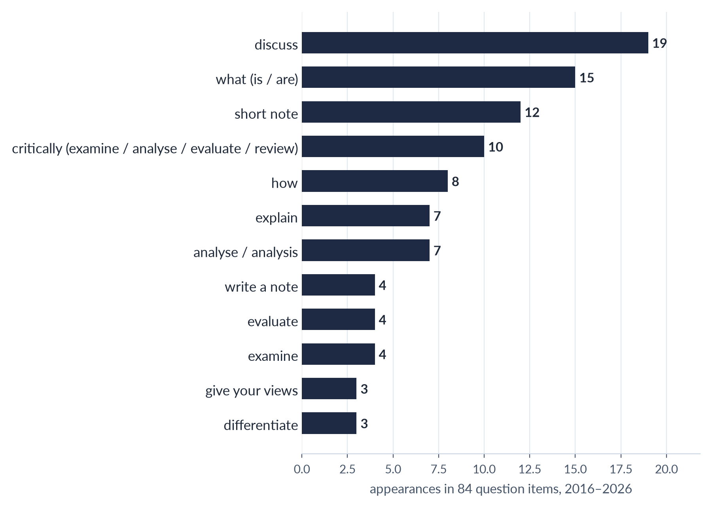
Figure 12 · The command words the examiner uses most (a question can use several).
Table 24 · What each command word demands.
Command | What the examiner wants
Define | The precise meaning, ideally with the source of the definition; then an example.
Differentiate / distinguish | The differences on stated criteria (a table is ideal), and a sentence on what the two share.
Discuss | Several sides of the issue, developed with evidence; your reasoned conclusion.
Explain / elaborate / elucidate | How and why something works; causes and mechanisms; examples.
Describe / outline | The main features in order, clearly; less argument, more coverage.
Trace | Development through time — phases, dates, turning points — in chronological order.
Critically analyse / examine / evaluate / review | The strengths and weaknesses, tested against evidence, ending in a judgement. Never only praise or only criticism.
Comment on (a statement) | Say whether and how far the statement is true, with evidence on both sides.
Give your views / in your opinion | A clear personal position — but argued with evidence, not asserted.
Compare | Similarities and differences, point by point.
What are / what is | Usually the first limb: definition plus a structured list; often followed by "how" or "why", which carries more marks.
Short notes | A compact, structured mini-answer; headings still help.

3.11 What changed between 2016 and 2026
Read in order, the eleven papers fall into three eras.
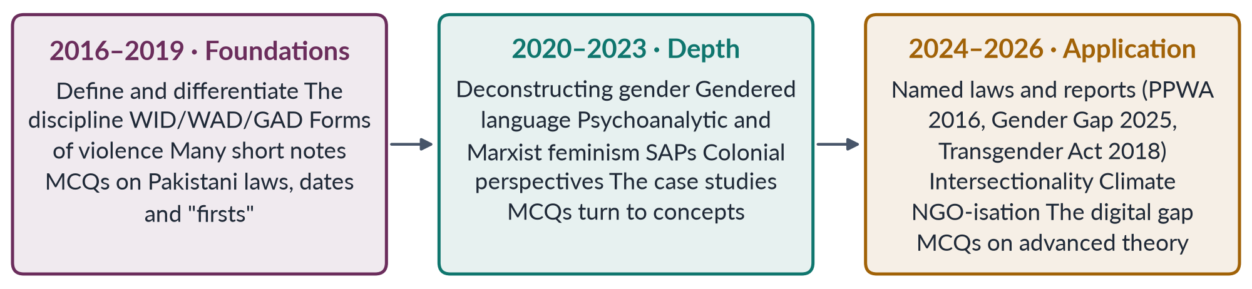
Figure 13 · Three eras of the Gender Studies paper.
Four shifts matter most for your preparation:
1. From "what" to "how far". Early questions asked what things are; recent ones ask you to evaluate, apply and critique. Description alone no longer scores.
2. From the syllabus to the world. Recent questions name reports, laws and statistics from the previous year or two. You need current facts, not only textbook theory.
3. From single topics to combinations. 2026 Q2 combines social construction, queer theory and Pakistani law; 2026 Q6 combines the movement with a development critique. Leaks are increasing.
4. Longer question stems. Several 2026 questions run to four or five lines, giving you facts to use (for example 2026 Q8(a) supplies the mobile-gap figures). Read them twice: the stem often contains the structure of the answer.

3.12 Where the next paper could come from
No one can predict a paper. But the record makes some questions much more likely than others. The tiers below guide how deeply to prepare each area. Every syllabus line is covered in the Knowledge Bases whatever its tier; the tiers decide how much practice-writing each deserves.

Tier 1 — prepare to full-answer depth from every angle
Area | Topic | Why, and the angle most likely next
Gender-based violence: forms, causes, theories, laws and strategies | T7 | Asked in 9 of 11 papers (ten items). Next angle: the new domestic-violence laws (Islamabad 2025); online violence; masculinities
WID, WAD, GAD (with Moser and Kabeer) | T4 | Five visits. Next angle: gender mainstreaming and its critics; GAD in Pakistan's programmes (BISP)
The waves of feminism and Pakistan | T3 | Five visits, including an exact repeat. Next angle: the fourth wave and digital feminism
The women's movement in Pakistan | T3 | Six items (with APWA/WAF and NGO-isation), two in 2026 alone. Next angle: Aurat March; NGO-isation; the backlash
Colonial, capitalist and development theories; globalisation | T4 | Twelve items in nine papers, across five families. Next angle: gendered globalisation and platform work; IMF programmes
Social construction, sex/gender, masculinities and queer theory | T1 | Seven items in seven papers. Next angle: the transgender law and the courts; masculinities
Political quotas and participation | T6 | Six items in six papers. Next angle: the 2024 elections; the 5% ticket rule; reserved seats disputes
Intersectionality | T2/T5 | Asked in both of the last two papers — a new favourite

Tier 2 — prepare to a full plan and a strong short answer
Area | Topic | Why
Autonomy vs integration; status of Gender Studies in Pakistan | T1 | Asked four times each, but not since 2023 — due for a return
Women's vs Gender Studies; multidisciplinary nature | T1 | Four and two visits; a reliable "define and differentiate" question
Radical, Marxist, psychoanalytic and postmodern feminism | T2 | Each asked once or twice; ideal short-note material
Women's health | T5 | Three visits (2017, 2023, 2024)
The Global Gender Gap and Pakistan's ranking | T5 | Asked 2018 and 2026; the 2026 report gives new figures
The three case studies | T7 | Each asked once — Mukhtaran Mai (2019), Obaid-Chinoy (2020), Malala (2025); the older two are due
Structural Adjustment Policies | T4 | Asked once (2022); IMF programmes make it topical
Masculinities | T1/T7 | Asked 2021, 2023 and 2026 (note)

Tier 3 — the blind spots most likely to be broken
Area | Topic | Why
Status of women in education | T5 | A whole syllabus line never asked; out-of-school girls; Malala links
UN Conferences on Women | T3 | Never a descriptive question; Beijing+30 (2025)
Women as voters; defining governance | T6 | Never asked; the electoral gender gap and the 10% rule
Men's feminism | T2 | Never asked in either part
Liberal feminism on its own | T2 | The most famous school, never asked alone
Women and law — family law, inheritance, the new child-marriage laws | T5 | Only one direct question in eleven years; 2025–2026 laws are new
Historicizing constructionism | T1 | A syllabus line never asked by name

Part Four — The Seven Topic Dossiers
Read each dossier just before you begin its topic. It tells you what the syllabus asks, what the examiner has asked, what the record reveals, what is new, what is likely next, the evidence you must carry, and exactly what the topic's two documents will teach.

T1 · Gender Studies and the Social Construction of Gender

What the syllabus asks for
Two heads, ten lines. Head I: an introduction to Gender Studies; the difference between Gender and Women's Studies; the multidisciplinary nature of the field; the autonomy versus integration debate; the status of Gender Studies in Pakistan. Head II: historicizing constructionism; problematizing "sex" through queer theory; whether sex is socially determined too; masculinities and femininity; and the nature versus culture debate in gender development.

What the examiner has asked
Table 25 · Every question the examiner has set on T1, 2016–2026.
Year · Q | The question (as set) | Family
2016 · Q2 | Write a note on the status of women's studies in Pakistan and give your views on the autonomy/integration debate in Women's Studies. | Status of Gender / Women's Studies in Pakistan; The autonomy versus integration debate
2016 · Q6 | What are the theories of social construction of gender? | Social construction of gender — theories; deconstructing 'gender'
2017 · Q2 | Define and discuss the discipline of Gender Studies and also differentiate between Women's Studies and Gender Studies. | Gender Studies as a discipline — meaning, need, scope; Women's Studies versus Gender Studies
2017 · Q7 | Write a comprehensive note on the autonomy versus integration debate in Gender Studies. | The autonomy versus integration debate
2018 · Q2 | What are the fundamental differences between Gender Studies and Women's Studies? Substantiate your argument(s) with examples. Highlight the current status of Women's Studies in Pakistan. | Women's Studies versus Gender Studies; Status of Gender / Women's Studies in Pakistan
2018 · Q3 | Write a comprehensive essay on the 'sex versus gender debate' in feminist philosophy and social sciences, reflecting the nature versus nurture argument. | Sex versus gender; is sex socially constructed; nature versus nurture
2019 · Q2 | How do you differentiate the discipline of Gender Studies from that of Women's Studies? Historically trace the need for the establishment of Gender Studies as a distinct discipline and its scope and significance, with special reference to Pakistan. | Gender Studies as a discipline — meaning, need, scope; Women's Studies versus Gender Studies; Status of Gender / Women's Studies in Pakistan
2020 · Q2 | Gender has multiple meanings. How do you deconstruct the word 'GENDER'? | Social construction of gender — theories; deconstructing 'gender'; Sex versus gender; is sex socially constructed; nature versus nurture
2020 · Q4 | 'Language is gendered.' What does this imply? Explain with examples. | Gendered language
2021 · Q2 | Discuss in detail how the autonomy and integration debate in Gender Studies has made an important contribution to the development of the field of knowledge. | The autonomy versus integration debate
2021 · Q3 | Masculinity and femininity are deeply engraved realities since the distant past in human history. Discuss various theoretical debates on their construction to make explicit whether the formation of both is a natural or social reality. Support your arguments with real-life examples. | Masculinities, femininities and gender roles; Sex versus gender; is sex socially constructed; nature versus nurture
2022 · Q2 | Discuss in detail the multidisciplinary nature of Gender Studies. | The multidisciplinary nature of Gender Studies
2023 · Q2 | Write a note on the status of Gender Studies in Pakistan. Give your views on the autonomy versus integration debate in Gender Studies. | Status of Gender / Women's Studies in Pakistan; The autonomy versus integration debate
2023 · Q3 | Differentiate between Gender Studies and Women's Studies. Discuss in detail the multidisciplinary nature of Gender Studies. | Women's Studies versus Gender Studies; The multidisciplinary nature of Gender Studies
2023 · Q4 | Define the terms masculinity and femininity. In your opinion, where do traditional gender roles come from? | Masculinities, femininities and gender roles
2024 · Q8(a) | Short note: Is 'sex' also a social construct? | Sex versus gender; is sex socially constructed; nature versus nurture
2026 · Q2 | Critically examine the theoretical arguments of social constructionism and queer theory regarding the categories of sex and gender. How do these arguments illuminate contemporary debates about transgender rights and the controversies over the Transgender Persons (Protection of Rights) Act 2018 in Pakistan? Support your answer with examples from legal debates and activism. | Queer theory and transgender rights; Social construction of gender — theories; deconstructing 'gender'

What the record reveals
- This is the second-heaviest topic (16.5 visits) and the most repetitive. The discipline half (Head I) has four families — Women's vs Gender Studies, the multidisciplinary nature, autonomy vs integration, and status in Pakistan — asked 14 times between them, often two families in one question (2016, 2018, 2019, 2023).
- The construction half (Head II) is where the difficulty is rising. It moved from "what are the theories of social construction?" (2016) to "deconstruct the word gender" (2020), to "masculinities — natural or social?" (2021), to queer theory applied to Pakistan's transgender law (2026).
- The examiner loves combined questions. Nearly half of T1's questions join two families. Prepare each family so that it can stand alone and be paired.
- The discipline half has been silent since 2023 — three years without autonomy/integration or status in Pakistan after seven appearances. Expect it back.

The contemporary layer
The Transgender Persons (Protection of Rights) Act 2018 and the Federal Shariat Court's judgment of 19 May 2023 (sections on self-perceived identity and inheritance held repugnant to Islam; an appeal before the Shariat Appellate Bench of the Supreme Court was still pending in 2026); the global "gender ideology" debate; masculinity in crisis and online misogyny; gender in school textbooks; the funding and growth of Gender Studies departments under the Higher Education Commission.

Blind spots and five likely questions
Blind spot: historicizing constructionism by name. Near-blind: "is sex socially determined?" as a full question (only a short note, 2024). Likely next:
1. "Trace the historical development of social constructionism in the study of gender. How has it changed our understanding of 'woman'?"
2. "Critically evaluate the achievements and challenges of Gender Studies as an academic discipline in Pakistan."
3. "Is biology destiny? Discuss the nature versus culture debate with reference to gender roles in Pakistani society."
4. "Explain Connell's concept of hegemonic masculinity. How does it help explain gender inequality in Pakistan?"
5. "Queer theory argues that even 'sex' is socially constructed. Critically examine this claim."

The core evidence in one page
Evidence | What to carry into the exam
Robert Stoller (1968); Ann Oakley (1972) | The sex/gender distinction — first in psychology, then in sociology
Simone de Beauvoir (1949) | "One is not born, but rather becomes, a woman"; woman as "the Other"
Margaret Mead (1935) | Sex and Temperament in Three Primitive Societies: the Arapesh, Mundugumor and Tchambuli show "masculine" and "feminine" traits vary by culture
Berger and Luckmann (1966) | The Social Construction of Reality — the general theory behind constructionism
Women's Studies (1969–70) | First course at Cornell (1969), first programme at San Diego State (1970); US National Women's Studies Association (1977)
Bowles and Klein (1983) | Theories of Women's Studies — the autonomy versus integration debate
Pakistan (1989) | Women's Studies centres set up by the federal government in five universities; today degree programmes at many universities
Foucault (1976); Butler (1990); Sedgwick (1990); de Lauretis (1991) | Power and sexuality; performativity; the homo/heterosexual binary; "queer theory"
Laqueur (1990); Fausto-Sterling (1993, 2000) | The one-sex model of history; the "five sexes" and the social decisions in classifying intersex bodies
West and Zimmerman (1987); Bem (1974) | "Doing gender"; androgyny and gender schema
Connell (1987, 1995) | Hegemonic, complicit, subordinated and marginalised masculinities
Supreme Court (2009); Transgender Act (2018); FSC (2023) | Recognition of the khawaja sira; self-perceived identity; the Islamic-law challenge

What the T1 documents will carry
Table 26 · T1KB — chapter plan (about 18,500 words).
Part | Content
Zero | The ABC: 30 key terms; the sex/gender picture; the whole topic on one page
Ch. 1 | What Gender Studies is — definitions, scope, aims and significance; why the discipline was needed
Ch. 2 | From Women's Studies to Gender Studies — the history since the 1960s; the differences on eight criteria; how they relate; men's studies and LGBTQ studies
Ch. 3 | The multidisciplinary nature — what each discipline contributes (ten disciplines); multi- vs inter- vs trans-disciplinary
Ch. 4 | The autonomy versus integration debate — Bowles and Klein; the case for each; the "dual strategy"; its contribution to knowledge; lessons for Pakistan
Ch. 5 | Gender Studies in Pakistan — history, institutions, research, achievements, problems and the way forward
Ch. 6 | Historicizing constructionism — from essentialism to constructionism; Mead, Beauvoir, Berger and Luckmann, Oakley, Foucault; the theories of social construction (socialisation, social learning, cognitive development, gender schema, doing gender, performativity)
Ch. 7 | Deconstructing "gender" — its many meanings; gendered language in English and Urdu
Ch. 8 | Problematizing "sex" — queer theory; is sex socially determined too? Laqueur, Fausto-Sterling, Butler; intersex; the counter-arguments
Ch. 9 | Masculinities and femininities — Connell's typology; emphasised femininity; where traditional roles come from; Pakistani examples
Ch. 10 | Nature versus culture — the biological case, the cultural case, interactionism; what the debate means for policy
Ch. 11 | The transgender debate in Pakistan — 2009, 2018, 2023; the arguments; the balanced view
Parts Two–Five | Contemporary debates · record and five likely questions · one-liners · revision sheet

T1QA will answer all 16 full questions and the 2024 short note on "is sex also a social construct?".

T2 · Feminist Theories and Practice

What the syllabus asks for
One head, seven lines: what feminism is, and six schools — liberal, radical, Marxist/socialist, psychoanalytic, men's and postmodern feminism.

What the examiner has asked
Table 27 · Every question the examiner has set on T2, 2016–2026.
Year · Q | The question (as set) | Family
2016 · Q7 | What is feminism? In what way is Radical Feminism different from Socialist Feminism? | What is feminism; schools of feminism compared; Radical feminism; Marxist / socialist feminism
2018 · Q4 | What type(s) of feminism can elevate the socio-cultural, economic and political status of women in Pakistan? | Which feminism suits Pakistan
2019 · Q8(b) | Short note: Postmodern Feminism | Postmodern feminism
2021 · Q4 | Marxist feminism is a philosophical variant of feminism that incorporates and extends Marxist theory and analyzes the ways in which women are exploited through capitalism and the individual ownership of private property. Discuss the development of Marxist/Socialist feminism and the philosophical stance it holds on gender issues and exploitation. | Marxist / socialist feminism
2021 · Q5 | Psychoanalytic feminism is a theory of oppression which asserts that men have an inherent psychological need to subjugate women. Give a detailed analysis of gender oppression and women's subordination promulgated by Psychoanalytic Feminism. | Psychoanalytic feminism
2022 · Q3 | Describe any two Western schools of thought about feminism in detail. | What is feminism; schools of feminism compared
2024 · Q8(b) | Short note: Radical Feminism | Radical feminism
2025 · Q6 | Give a detailed analysis of the intersectionality of gender with other social identities. | Intersectionality

What the record reveals
- Light in the descriptive paper, heavy in the objective paper. Only seven visits (the lightest topic), but 26 of 140 MCQs — second only to T1 — and 12 of the 40 MCQs in 2025–2026.
- The examiner prefers comparison and application to recitation. "How is radical feminism different from socialist feminism?" (2016); "which feminism can elevate women's status in Pakistan?" (2018); "describe any two Western schools" (2022).
- Intersectionality has arrived. Not in the syllabus, yet asked as theory in 2025 and applied to Pakistan in 2026. It is the single most important addition to this topic.
- Two schools have never been asked: men's feminism (never) and liberal feminism on its own.

The contemporary layer
Is feminism a "Western import"? — the answer from South Asian history (Bhasin and Khan) and from Muslim feminists (Wadud, Mernissi, Riffat Hassan); intersectionality in Pakistan; ecofeminism and climate justice; the online backlash against feminism and the "manosphere"; men as allies (HeForShe, 2014).

Blind spots and five likely questions
1. "What is men's feminism? Can men be feminists? Discuss with reference to masculinity studies."
2. "Liberal feminism is the most influential but the most criticised school of feminist thought. Discuss."
3. "Compare the explanations of women's oppression offered by radical and Marxist feminism. Which is more relevant to Pakistan?"
4. "Postmodern feminism denies that there is a single category 'woman'. Is this a strength or a weakness for feminist politics?"
5. "Feminism is often dismissed as a Western concept. Critically examine this view in the South Asian context."

The core evidence in one page
Evidence | What to carry into the exam
Liberal | Wollstonecraft (1792); Mill (1869); Friedan (1963); the US National Organization for Women (1966); equal rights, education and law
Radical | Millett, Sexual Politics (1970); Firestone, The Dialectic of Sex (1970); "the personal is political" (Carol Hanisch, 1969–70); patriarchy as the root oppression
Marxist | Engels (1884): "the world historical defeat of the female sex"; women's oppression began with private property and the monogamous family
Socialist | Hartmann (1979): dual systems; Juliet Mitchell (1971, 1974); domestic labour debate; wages for housework campaign (1970s)
Psychoanalytic | Freud's Oedipus complex and "penis envy"; Horney's "womb envy"; Chodorow (1978); Mitchell (1974); Lacan, Irigaray, Kristeva, Cixous
Men's feminism | Connell; Michael Kimmel; bell hooks, Feminism Is for Everybody (2000); UN Women's HeForShe (2014); MenEngage
Postmodern | Butler (1990); Cixous, "The Laugh of the Medusa" (1975); Irigaray; Kristeva; Lyotard's distrust of grand narratives
Intersectionality | Crenshaw (1989); Collins's matrix of domination (1990); the Combahee River Collective (1977)
Postcolonial | Mohanty, "Under Western Eyes" (1984/86); Spivak (1988)
Muslim feminism | Amina Wadud, Qur'an and Woman (1992); Fatima Mernissi, The Veil and the Male Elite (1987; English 1991); Riffat Hassan

What the T2 documents will carry
Table 28 · T2KB — chapter plan (about 17,500 words).
Part | Content
Zero | The ABC: 30 key terms; the family tree of feminism; the four questions every school answers (cause, site, remedy, method)
Ch. 1 | What is feminism — definitions, core beliefs, myths about the word, feminism in South Asia
Ch. 2 | Liberal feminism — origins, thinkers, claims, achievements, critique, relevance to Pakistan
Ch. 3 | Radical feminism — patriarchy, sexuality, the body; cultural vs radical-libertarian; critique
Ch. 4 | Marxist and socialist feminism — Engels; the domestic-labour debate; dual systems; critique; the 2021 question in full
Ch. 5 | Psychoanalytic feminism — Freud and his critics; object-relations theory; the French school; critique; the 2021 question in full
Ch. 6 | Men's feminism — pro-feminist men, masculinity studies, HeForShe; can men be feminists?
Ch. 7 | Postmodern and post-structural feminism — difference, discourse, deconstruction; strengths and dangers
Ch. 8 | Beyond the syllabus — intersectionality and Black feminism; postcolonial; ecofeminism; Muslim feminism; standpoint theory; the concepts the MCQs ask (kyriarchy, strategic essentialism, patriarchal bargain)
Ch. 9 | The schools compared — one master table; which feminism suits Pakistan (2018)
Parts Two–Five | Contemporary debates · record and five likely questions · one-liners · revision sheet

T3 · Feminist Movements — the West, the United Nations and Pakistan

What the syllabus asks for
One head, three strands: the first, second and third waves of feminism in the West; the United Nations conferences on women; and feminist movements in Pakistan.

What the examiner has asked
Table 29 · Every question the examiner has set on T3, 2016–2026.
Year · Q | The question (as set) | Family
2016 · Q5 | Write a note on women's movement in Pakistan. What are its strengths and weaknesses? | The women's movement in Pakistan
2018 · Q8(b) | Short note: APWA and WAF | APWA and WAF
2019 · Q3 | Outline and explain the three major waves of feminist movements in the West. Discuss the influence of these waves on feminist movements in Pakistan. | The waves of Western feminism and their influence on Pakistan
2022 · Q4 | Shed light on the first wave and third wave of feminism. | The waves of Western feminism and their influence on Pakistan
2022 · Q6 | Discuss in detail feminist movements in Pakistan. | The women's movement in Pakistan
2023 · Q5 | Outline and explain the three major waves of feminist movements in the West. Discuss the influence of these waves on feminist movements in Pakistan. | The waves of Western feminism and their influence on Pakistan
2024 · Q4 | Write in detail the impact of Western feminist movements on the feminist movement in Pakistan. Compare Pakistani feminist movements of the past with emerging trends of feminist activism and their effects. | The waves of Western feminism and their influence on Pakistan; The women's movement in Pakistan
2025 · Q4 | Discuss the key principles, goals and strategies of the different waves of feminism. How have these waves affected women's lives? | The waves of Western feminism and their influence on Pakistan
2026 · Q3 | Trace the evolution of the feminist movement in Pakistan, from the activism of the Women's Action Forum (WAF) against the Hudood Ordinances in the 1980s to the digital activism of the 2020s. How has the locus of resistance shifted from 'legal rights' to 'bodily autonomy'? | The women's movement in Pakistan
2026 · Q6 | Critically examine the 'NGO-ization' of the women's movement in Pakistan. Has the donor-driven agenda of gender mainstreaming depoliticized the feminist struggle, converting it into a technocratic 'project' rather than a social revolution? Use the WAD (Women and Development) critique in your answer. | NGO-isation of the women's movement; WID, WAD and GAD

What the record reveals
- Two families carry the topic: the waves (five times, including one exact repeat) and the movement in Pakistan (four times, plus APWA/WAF and NGO-isation).
- The examiner always wants the link. Four of the five waves questions ask how the waves influenced Pakistan, or how they affected women's lives. Western history alone is half an answer.
- The Pakistani movement is asked with a twist each time: strengths and weaknesses (2016), past versus emerging trends (2024), the shift from "legal rights" to "bodily autonomy" (2026), and NGO-isation (2026).
- The UN conferences have never been a descriptive question, although the MCQs love them.

The contemporary layer
Aurat March (since 8 March 2018) and the controversy over its slogans; the fourth wave and the reception of #MeToo in Pakistan; Beijing+30 (2025); CEDAW reporting and the committee's observations on Pakistan; NGO-isation and donor dependence; digital activism and online backlash; the global anti-gender movement.

Blind spots and five likely questions
1. "Critically evaluate the contribution of the four UN World Conferences on Women to the global women's movement. What has Beijing+30 revealed?"
2. "Is there a fourth wave of feminism? Discuss its features and its expression in Pakistan."
3. "The Aurat March has divided Pakistani society. Discuss its demands, its critics and its significance."
4. "Discuss the role of the Women's Action Forum in the struggle against discriminatory laws in the 1980s."
5. "How far has the women's movement in Pakistan succeeded in translating activism into law?"

The core evidence in one page
Evidence | What to carry into the exam
First wave | Seneca Falls (1848) and the Declaration of Sentiments; NUWSS (1897) and WSPU (1903); New Zealand (1893); UK (1918, 1928); USA (1920)
Second wave | Martha Lear names the "second wave" (1968); Friedan (1963); NOW (1966); Equal Pay Acts (US 1963; UK 1970); Roe v. Wade (1973)
Third and fourth waves | Rebecca Walker, "Becoming the Third Wave" (1992); Riot Grrrl; #MeToo (Tarana Burke 2006; global 2017)
The UN | CSW (1946); International Women's Year (1975); Mexico City (1975), Copenhagen (1980), Nairobi (1985), Beijing (1995; 189 states; 12 critical areas); CEDAW (1979/1981); UNSCR 1325 (2000); UN Women (2010); SDG 5 (2015)
Pakistan: roots | Fatima Jinnah; Begum Jahanara Shahnawaz and Begum Shaista Ikramullah; women in the Pakistan Movement
Pakistan: phases | APWA (1949); MFLO (1961); 1973 Constitution; Hudood (1979) and WAF (1981); 12 February 1983; Beijing and NGOs (1990s); NCSW (2000); Women's Protection Act (2006); laws of 2010–2016; Aurat March (2018–)
Scholarship | Mumtaz and Shaheed (1987); Bhasin and Khan; Alvarez and Jad on NGO-isation

What the T3 documents will carry
Table 30 · T3KB — chapter plan (about 17,000 words).
Part | Content
Zero | The ABC: 25 key terms; the wave metaphor and its critics; the whole topic on one timeline
Ch. 1 | The first wave — suffrage and legal personhood in the USA, Britain and New Zealand; suffragists and suffragettes
Ch. 2 | The second wave — work, family, sexuality and the body; its achievements and blind spots
Ch. 3 | The third wave — diversity, identity and culture; critique
Ch. 4 | The fourth wave — digital activism, #MeToo; features and critics
Ch. 5 | The waves compared — principles, goals, strategies and effects on women's lives (2025)
Ch. 6 | The United Nations and women — CSW, the four conferences, CEDAW, the reviews, UN Women, SDG 5, Women, Peace and Security
Ch. 7 | Roots of the movement in South Asia — reformers, women in the Pakistan Movement
Ch. 8 | The movement in Pakistan, phase by phase — 1947 to today; APWA and WAF compared
Ch. 9 | The influence of the Western waves on Pakistan; past versus emerging trends (2019, 2023, 2024)
Ch. 10 | NGO-isation — the debate, the WAD critique, the evidence (2026)
Ch. 11 | Evaluation — strengths, weaknesses, achievements and the way forward
Parts Two–Five | Contemporary debates · record and five likely questions · one-liners · revision sheet

T3QA will answer all 9 full questions (the exact repeat of 2019 and 2023 answered once, with a note) and the APWA/WAF short note.

T4 · Gender and Development

What the syllabus asks for
One head, four lines, but the densest in the syllabus: colonial and capitalist perspectives of gender; gender analysis of four development theories (modernisation, world-system, dependency, structural functionalism); the WID, WAD and GAD approaches and the gender critique of structural adjustment; and globalisation and gender.

What the examiner has asked
Table 31 · Every question the examiner has set on T4, 2016–2026.
Year · Q | The question (as set) | Family
2016 · Q8 | Critically review the Gender and Development approaches: (i) Women in Development (WID), (ii) Women and Development (WAD), and (iii) Gender and Development (GAD). | WID, WAD and GAD
2017 · Q6 | 'Powerful forces of globalization have highlighted various gender issues across cultures and throughout the globe.' Discuss by quoting examples from developing countries. | Globalisation and gender
2017 · Q8(b) | Short note: Gender and development | WID, WAD and GAD
2018 · Q6 | In the last two decades, globalization has had a huge impact on the lives of women in developing nations, including Pakistan. What are the impacts of the global political economy on Pakistani women? | Globalisation and gender
2018 · Q8(a) | Short note: Gender Strategic Needs and Gender Practical Needs | Practical and strategic gender needs
2019 · Q4 | Explain the relevance of Modernization Theory and Dependency Theory to gender equality. Critically analyze the subordination of women in modern societies in the light of these two theories. | Modernisation (and dependency) theory; Gender analysis of development theories
2019 · Q5 | The process of globalization has connected nations worldwide and made the world a global village, yet it has also increased inequalities across nations. Discuss the gendered inequalities created and promoted by globalization in contemporary societies worldwide. | Globalisation and gender
2019 · Q8(c) | Short note: Structural Functionalism | Structural functionalism
2020 · Q3 | How did the colonial era influence the status of women in the subcontinent? | Colonial and capitalist perspectives of gender
2021 · Q6 | Modernization Theory blames internal cultural factors for women's subordination in the developing world. Discuss and elaborate the statement in respect of Modernization perspectives. | Modernisation (and dependency) theory
2021 · Q7 | Critically analyze the various approaches to women's development, focusing on Women in Development (WID), Women and Development (WAD), and Gender and Development (GAD). | WID, WAD and GAD
2022 · Q7 | What are the capitalistic perspectives of gender? Explain. | Colonial and capitalist perspectives of gender
2022 · Q8 | Discuss in detail the gender critique of Structural Adjustment Policies (SAPs). | Gender critique of Structural Adjustment Policies
2023 · Q6 | Write a detailed note on the colonial and capitalistic perspectives of gender. | Colonial and capitalist perspectives of gender
2024 · Q3 | Write a note on the colonial and capitalistic perspectives of gender. Throw light on the thesis that development is the new name of coloniality in the context of emerging perspectives of gender. | Colonial and capitalist perspectives of gender
2024 · Q5 | Give a critical gender analysis of development theories. | Gender analysis of development theories
2025 · Q3 | Critically evaluate the concept of 'gendered globalisation', focusing on World-System Theory and how the globalisation of capitalism has created new forms of patriarchal power that increase gender inequalities. | Globalisation and gender; Gender analysis of development theories
2025 · Q7 | Critically analyze Women in Development (WID) and Gender and Development (GAD) models. Discuss their basic principles and limitations in addressing women's needs in developing countries. | WID, WAD and GAD
2026 · Q5 | Climate change has gendered impacts. Drawing on feminist environmentalism and ecofeminist perspectives, critically analyse how recent floods and heat waves in Pakistan have affected women differently. | Gender, climate change and ecofeminism

What the record reveals
- The heaviest topic (17.5 visits), and the only one present in every paper.
- Three strong families: WID/WAD/GAD (five times), colonial and capitalist perspectives (four times, 2020–2024 in a row), and globalisation (four times). Development theories come up three more times.
- The examiner wants critique, not description: "critically review", "critically analyse", "give a critical gender analysis", "critically evaluate". A description of WID, WAD and GAD without their limitations cannot score well.
- The newest questions join theory to the present: development as the "new name of coloniality" (2024), gendered globalisation and world-system theory (2025), climate change and ecofeminism (2026).

The contemporary layer
The 2022 floods (a third of Pakistan under water; an estimated 650,000 pregnant women affected, according to UNFPA) and recurrent heat waves; the care economy and unpaid work; gender budgeting in Pakistan's budgets; the SDGs at mid-point; IMF programmes and austerity; platform and gig work; artificial intelligence and women's jobs.

Blind spots and five likely questions
1. "Explain world-system theory. How does it explain the position of women in the global economy?"
2. "Distinguish between practical gender needs and strategic gender interests. Why does the distinction matter for development planning in Pakistan?"
3. "What is gender mainstreaming? Critically evaluate its achievements since Beijing 1995."
4. "Assess the gendered impact of IMF-supported stabilisation programmes on women in Pakistan."
5. "Unpaid care work is the hidden foundation of the economy. Discuss with reference to feminist economics."

The core evidence in one page
Evidence | What to carry into the exam
Colonial | British reforms: the sati ban (1829), the Widow Remarriage Act (1856), the Child Marriage Restraint Act (1929); the "civilising mission"; Mohanty and Spivak on the colonial gaze; Lugones (2007) on the coloniality of gender; Escobar (1995) on development discourse
Capitalist | Engels (1884); Maria Mies (1986) on "housewifisation"; the domestic-labour debate; public/private split
Modernisation | Rostow, The Stages of Economic Growth (1960); "trickle-down"; blamed "tradition" for women's subordination
Dependency / world-system | Frank and Prebisch (core–periphery); Wallerstein (1974): core, semi-periphery, periphery; the gendered global assembly line
Structural functionalism | Parsons and Bales (1955): men's instrumental and women's expressive roles; critique as a justification of inequality
WID / WAD / GAD | Boserup (1970); the Percy Amendment (US, 1973); WAD's Marxist critique (late 1970s); GAD and DAWN (1984–85); Kate Young; Moser (1993); Molyneux (1985); Kabeer (1994, 1999)
SAPs | IMF/World Bank from the 1980s; UNICEF's Adjustment with a Human Face (1987); Diane Elson on male bias (1991)
Globalisation | Feminisation of labour (Standing, 1989); global care chains (Hochschild, 2000); export processing zones; remittances
Climate | Ecofeminism (d'Eaubonne, 1974; Shiva, 1988); feminist environmentalism (Agarwal, 1992); the 2022 floods

What the T4 documents will carry
Table 32 · T4KB — chapter plan (about 19,000 words).
Part | Content
Zero | The ABC: 35 key terms; "development for whom?"; the whole topic on one diagram
Ch. 1 | What development is, and why gender matters to it
Ch. 2 | Colonial perspectives of gender — British India; the colonial gaze; reform and its limits (2020, 2023, 2024)
Ch. 3 | Capitalist perspectives of gender — Engels to Mies; development as coloniality (2022, 2023, 2024)
Ch. 4 | A gender analysis of modernisation theory (2019, 2021)
Ch. 5 | Dependency theory and gender
Ch. 6 | World-system theory and gender (2025)
Ch. 7 | Structural functionalism and gender (2019)
Ch. 8 | The development theories compared — one critical table (2024)
Ch. 9 | Women in Development (WID)
Ch. 10 | Women and Development (WAD)
Ch. 11 | Gender and Development (GAD); Moser's needs and roles; Kabeer's empowerment; gender mainstreaming — the three approaches compared
Ch. 12 | The gender critique of Structural Adjustment Policies (2022)
Ch. 13 | Globalisation and gender — benefits, harms, "gendered globalisation" (2017, 2018, 2019, 2025)
Ch. 14 | Gender, environment and climate change — ecofeminism, feminist environmentalism, Pakistan's floods (2026)
Ch. 15 | From the MDGs to the SDGs — the global goals and Pakistan
Parts Two–Five | Contemporary debates · record and five likely questions · one-liners · revision sheet

T5 · Status of Women in Pakistan

What the syllabus asks for
One head, four lines: women's health, education, employment, and law.

What the examiner has asked
Table 33 · Every question the examiner has set on T5, 2016–2026.
Year · Q | The question (as set) | Family
2017 · Q5 | What is the status of women's health in Pakistan? How could it be improved within the available economic resources? | Women's health in Pakistan
2018 · Q5 | What reasons are responsible for ranking Pakistan as the second-worst country in the world for gender inequality despite Pakistan's commitment to many international conventions and the strong commitment to gender equality in the 1973 Constitution? | Pakistan and the Global Gender Gap; Women, law and human rights
2019 · Q6 | Women's participation in the labour force has increased recently, yet women continue to perform their reproductive roles. Discuss the challenges encountered by women as a result of paid employment worldwide, with special reference to Pakistan. | Women and paid employment
2020 · Q6 | 'For realizing, in letter and spirit, the ideals of a democratic welfare state, it is necessary to institute a system which fully guarantees human rights, generates a conducive environment for the pragmatic use and beneficial enjoyment of human rights, and provides operative safeguards and expeditious remedy against any violation of human rights.' Critically evaluate the statement with special reference to Pakistan. | Women, law and human rights
2023 · Q7 | Elucidate the current health status of women in Pakistan. What measures could be taken to improve women's status as a whole? Support your arguments with suitable examples. | Women's health in Pakistan
2024 · Q2 | An Egyptian doctor, Mahmoud Fathalla, uses the term 'maternity death road' while discussing issues of women's maternal health. Discuss women's health issues in the context of Pakistan's social, cultural and demographic situation. | Women's health in Pakistan
2026 · Q4 | Evaluate Pakistan's performance in the World Economic Forum's Global Gender Gap Report 2025. Identify the socio-economic and political factors contributing to Pakistan's ranking, including labour-force participation, education, health and political empowerment. | Pakistan and the Global Gender Gap
2026 · Q7 | Using intersectionality as an analytical framework, examine the experiences of marginalized groups of women in Pakistan, including rural women, ethnic and religious minorities, and differently-abled women. How do overlapping systems of oppression shape their access to health, education and employment? | Intersectionality
2026 · Q8(a) | Short note: Gendered implications of digital transformation and the narrowing mobile gender gap in Pakistan (2024-2025), including the fact that eight million more women came online and the mobile internet gender gap fell from 38% to 25% | The digital gender gap

What the record reveals
- Health is the favourite line (2017, 2023, 2024). The 2024 question even quoted a named doctor (Mahmoud Fathalla and "the road to maternal death").
- Education has never been a full question — the clearest blind spot in the paper.
- The topic is where the newest questions land: Pakistan's gender-gap ranking (2018, 2026), intersectional disadvantage (2026), the digital gender gap (2026).
- This topic feeds every other. Almost every applied question in T3, T4, T6 and T7 needs its data and laws.

The contemporary layer
The Global Gender Gap Report 2026 (Pakistan 143rd of 145, up from last in 2025); female labour-force participation of 24.4% (LFS 2024–25); female literacy about 53% (Census 2023); out-of-school girls; child-marriage laws in Islamabad (2025) and Punjab (2026); the digital gender gap (the GSMA's figures: the mobile-internet gap narrowing from 38% to 25%); maternal and mental health; the 2022 floods; inheritance in practice.

Blind spots and five likely questions
1. "Discuss the status of women's education in Pakistan. What are the causes of the gender gap, and how can it be closed?"
2. "Pakistan has a strong body of pro-women laws but weak implementation. Critically examine."
3. "Why is female labour-force participation in Pakistan among the lowest in the world? Suggest a policy response."
4. "Evaluate the rights of women under the Constitution of Pakistan and the Muslim Family Laws Ordinance 1961."
5. "Women's health in Pakistan is a development issue, not only a medical one. Discuss."

The core evidence in one page
Evidence | What to carry into the exam
Constitution (1973) | Art. 25 (equality; special provision for women allowed), 26–27 (no discrimination in public places and services), 32 (women in local government), 34 (full participation of women), 35 (protection of family, mother and child), 37(e) (maternity benefits), 38; reserved seats (Art. 51, 59, 106)
Health | Maternal mortality ratio 186 per 100,000 live births (PMMS 2019); high anaemia and stunting; Fathalla's "road to maternal death" (1987)
Education | Literacy: about 68% men, 53% women (Census 2023); more than 25 million children out of school, most of them girls
Employment | Female LFPR 24.4% (LFS 2024–25; Punjab highest, Balochistan lowest); women concentrated in agriculture and informal home-based work; 10% quota for women in federal services
Family law | Dissolution of Muslim Marriages Act (1939); MFLO (1961); Family Courts Act (1964); child-marriage laws (Sindh 2013; Islamabad 2025; Punjab 2026)
Protective laws | Women's Protection Act (2006); harassment (2010); acid (2011); anti-women practices (2011); honour (2016); rape (2016, 2021); Enforcement of Women's Property Rights Act (2020); domestic violence (provinces from 2013; Islamabad 2025)
Indices | Global Gender Gap 2026: 143rd of 145, 59.5%; economic participation 144th; education 130th; political empowerment 107th
Institutions | NCSW (2000); provincial commissions; Ministry of Human Rights; women's protection centres; BISP payments to women

What the T5 documents will carry
Table 34 · T5KB — chapter plan (about 17,000 words).
Part | Content
Zero | The ABC: 30 key terms; how "status" is measured; the constitutional framework
Ch. 1 | Measuring women's status — the Global Gender Gap, GII and GDI; Pakistan's record since 2006 (2018, 2026)
Ch. 2 | Women's health — maternal, reproductive, nutritional and mental health; causes; policy; the way forward (2017, 2023, 2024)
Ch. 3 | Women's education — literacy, enrolment, dropout, higher education; causes; policy; the way forward
Ch. 4 | Women and employment — participation, sectors, the informal economy, wage gaps, harassment, care work; the double burden (2019)
Ch. 5 | Women and law — the Constitution; family law; criminal law from the Hudood Ordinances to the 2006 Act; protective laws; inheritance; the enforcement gap; human rights (2020)
Ch. 6 | Intersectional disadvantage — rural, minority, disabled and poor women (2026)
Ch. 7 | The digital gender gap — access, skills, safety; the 2024–25 progress (2026)
Ch. 8 | Climate change and women in Pakistan — floods, heat, health, livelihoods (2026, with T4)
Parts Two–Five | Contemporary debates · record and five likely questions · one-liners · revision sheet

T6 · Gender and Governance

What the syllabus asks for
One head, six lines: defining governance; the suffragist movement; gender issues in women as voters, as candidates and as representatives; and the impact of the political quota in Pakistan.

What the examiner has asked
Table 35 · Every question the examiner has set on T6, 2016–2026.
Year · Q | The question (as set) | Family
2016 · Q4 | What are the pros and cons of gender quota in politics? Give your views on the impact of gender quota in politics in Pakistan. | Political quotas for women
2017 · Q4 | 'Women's active political participation could stabilize democracy and boost economic development.' Comment on this statement within the context of the socio-economic realities of Pakistani society. | Women's political participation
2018 · Q7 | Believing in the statement that 'women cover half the sky', do you think we need an equal number of women in all spheres of the public domain, especially in politics? | Women's political participation
2019 · Q8(a) | Short note: Suffragist movement | The suffragist movement
2020 · Q5 | Women need to be in leadership positions to pull more women into leadership roles. Is this suggestion that women need to 'pull each other up' useful, or is it inappropriate preferential treatment? | Women in leadership
2021 · Q8 | Despite the entry of women legislators into politics on a 17 percent quota in national and provincial assemblies, there are still voices asking, 'Is Pakistan's gender quota in parliament showing results?' Rethink and discuss how quotas can lead to the political mainstreaming of women in Pakistan. | Political quotas for women
2022 · Q5 | In your opinion, what are the main issues faced by women as representatives in Pakistan? | Women as representatives / politicians
2024 · Q7 | Is political participation a human right? If so, what obstacles are faced by women politicians in Pakistan in pursuing a career in politics? What is the impact of the political quota system on this? | Women's political participation; Political quotas for women
2025 · Q5 | Elaborate the historical context and evolution of women's quota in Pakistan concerning key legislation and policies that have shaped the quota system. | Political quotas for women

What the record reveals
- The quota is the heart of the topic (2016, 2021, 2024, 2025), always with an evaluative twist: pros and cons, whether it shows results, its impact, its history.
- Participation is asked as a value question (2017: does it stabilise democracy?; 2018: should women have equal numbers?; 2020: should women "pull each other up"?; 2024: is participation a human right?).
- Three syllabus lines are blind spots: defining governance, women as voters, and women as candidates on their own.

The contemporary layer
The 2024 general election (only 11 women won general National Assembly seats); the Elections Act 2017 (section 206: at least 5% of general-seat tickets to women; section 9: the Election Commission may void a poll where women's turnout is below 10%); the gender gap in the electoral rolls (about 10 million more men than women registered in 2024); Maryam Nawaz as Pakistan's first woman chief minister (Punjab, 2024); the zero women ministers noted in the 2025 gap report; the 2026 bills for 33% women on federal boards.

Blind spots and five likely questions
1. "Define governance. Why is gender equality essential to good governance?"
2. "Discuss the gender issues faced by women as voters in Pakistan, with reference to electoral reforms."
3. "What obstacles do women face as candidates in Pakistan's elections? How can political parties help?"
4. "Descriptive representation does not guarantee substantive representation. Discuss with reference to women legislators in Pakistan."
5. "Trace the history of the suffragist movement. What lessons does it hold for women's political participation today?"

The core evidence in one page
Evidence | What to carry into the exam
Governance | UNDP (1997): participation, rule of law, transparency, responsiveness, consensus, equity, effectiveness, accountability, strategic vision; World Bank's six governance indicators
Suffrage | New Zealand (1893); Finland (1906: first to let women stand); UK (1918/1928); USA (1920); Millicent Fawcett (NUWSS) and Emmeline Pankhurst (WSPU)
Rights | UDHR Art. 21; ICCPR Art. 25; CEDAW Arts. 7–8; Beijing's critical area G ("women in power and decision-making")
Quota history | 1956 and 1962 constitutions (small reserved quotas); 1973 (10 seats); 1985 (20 seats); the provision lapsed and the 1990, 1993 and 1997 assemblies had no reserved seats; restored 2002 (60 NA, 17 Senate, 128 provincial — 132 after the FATA merger; 33% in local councils from 2000–2001); Elections Act 2017
Voters | Gender gap in electoral rolls (about 10 million, 2024); CNIC registration drives; 10% turnout rule
Representatives | Farzana Bari's assessment (2002); the Women's Parliamentary Caucus (2008); women's private members' bills
Leaders | Fatima Jinnah (1965 election); Benazir Bhutto (PM 1988–90, 1993–96); Fahmida Mirza (first woman Speaker, 2008); Maryam Nawaz (first woman CM, 2024)
Theory | Critical mass (about 30%; Dahlerup); descriptive vs substantive representation (Pitkin, 1967); Hoodfar and Tajali (2011) on quotas

What the T6 documents will carry
Table 36 · T6KB — chapter plan (about 16,000 words).
Part | Content
Zero | The ABC: 25 key terms; the ladder of participation from voter to leader
Ch. 1 | Defining governance — and why it is gendered
Ch. 2 | The suffragist movement — Britain, the USA, New Zealand; South Asia; lessons (2019)
Ch. 3 | Political participation as a human right (2024)
Ch. 4 | Gender issues in women as voters
Ch. 5 | Gender issues in women as candidates
Ch. 6 | Gender issues in women as representatives (2022)
Ch. 7 | Quotas — theory and types; the history in Pakistan; impact; pros and cons (2016, 2021, 2024, 2025)
Ch. 8 | Women in leadership — does it help to "pull each other up"? (2020); women and democracy and development (2017, 2018)
Parts Two–Five | Contemporary debates · record and five likely questions · one-liners · revision sheet

T7 · Gender-Based Violence and the Three Case Studies

What the syllabus asks for
Two heads. Head VIII: defining gender-based violence; theories of violence against women; structural and direct forms of violence; strategies to eliminate violence against women. Head IX: case studies of Mukhtaran Mai, Malala Yousafzai and Sharmeen Obaid-Chinoy.

What the examiner has asked
Table 37 · Every question the examiner has set on T7, 2016–2026.
Year · Q | The question (as set) | Family
2016 · Q3 | What are the sites and forms of violence against women in Pakistan and how in your view this menace can be eliminated from our society? | GBV — forms, sites and strategies to eliminate it
2017 · Q3 | What are the different forms of gender-based violence and, in your opinion, what could be the workable strategies to eliminate gender-based violence from Pakistani society? | GBV — forms, sites and strategies to eliminate it
2017 · Q8(a) | Short note: Honour killing | Honour killing
2018 · Q8(c) | Short note: Government initiatives for combating violence against women | GBV — laws and state initiatives
2019 · Q7 | Explain the structural and direct forms of violence against women in Pakistani society by highlighting the case study of Mukhtaran Mai. | GBV — forms, sites and strategies to eliminate it; Case study — Mukhtaran Mai
2020 · Q7 | Comment on the power-and-control relationship in gender-based violence. | GBV — causes, theories, power and control
2020 · Q8 | Discuss the background of the two Oscar-winning documentaries by Sharmeen Obaid-Chinoy. | Case study — Sharmeen Obaid-Chinoy
2023 · Q8 | Define gender-based violence. Explain various forms of violence against women in Pakistan and devise practical strategies helpful in eradicating gender-based violence from our society. | GBV — forms, sites and strategies to eliminate it
2024 · Q6 | What is gender-based violence? What forms of gender-based violence are given in the Punjab Protection of Women Against Violence Act 2016? What are the consequences of gender-based violence for women? | GBV — laws and state initiatives; GBV — forms, sites and strategies to eliminate it
2025 · Q2 | What are the root causes that lead to gender-based violence? How do these factors intersect and perpetuate violence against women in Pakistan? | GBV — causes, theories, power and control
2025 · Q8 | Critically examine and evaluate Malala Yousafzai's achievements and activism for promoting girls' education in local and global contexts. | Case study — Malala Yousafzai
2026 · Q8(b) | Short note: The role of masculinity studies in understanding violence against women in Pakistani society | Masculinities and violence against women

What the record reveals
- The most regular family in the paper. Violence against women appears in nine of eleven papers; "forms and strategies" alone five times.
- The questions escalate in depth: forms (2016, 2017), structural and direct with a case study (2019), power and control (2020), the Punjab Act of 2016 (2024), root causes and how they intersect (2025), masculinity studies (2026).
- Each case study has been asked once, always as "discuss the background" or "critically examine", never as a bare biography.
- Law is now named in the question (the Punjab Protection of Women against Violence Act 2016, in 2024). Knowing the laws section by section pays.

The contemporary layer
The Islamabad Domestic Violence (Prevention and Protection) Act 2025; online harassment and blackmail under PECA 2016; honour killings and femicide in HRCP data; jirga "justice"; masculinity and violence; Mukhtaran Mai's schools, Malala's global advocacy and the Malala Fund, Sharmeen Obaid-Chinoy's later work.

Blind spots and five likely questions
1. "Explain Galtung's concepts of direct, structural and cultural violence with examples from Pakistan."
2. "Critically evaluate Pakistan's legal framework against gender-based violence. Why does violence persist?"
3. "Discuss the Mukhtaran Mai case as an example of the failure and the resilience of justice in Pakistan."
4. "How did Sharmeen Obaid-Chinoy's documentaries influence legislation in Pakistan?"
5. "Technology-facilitated violence is the new frontier of GBV. Discuss with reference to Pakistan."

The core evidence in one page
Evidence | What to carry into the exam
Definitions | UN Declaration on the Elimination of Violence against Women (1993); CEDAW General Recommendations 19 (1992) and 35 (2017)
Scale | WHO: about 1 in 3 women worldwide experience physical or sexual violence in their lifetime; HRCP annual honour-killing figures
Theories | Feminist/power and control (Duluth wheel, 1981); social learning (Bandura); the cycle of violence (Walker, 1979); resource theory (Goode, 1971); the ecological model (Heise, 1998)
Forms | Galtung: direct (1969), structural (1969), cultural (1990); the life-cycle of violence from sex-selection to elder abuse
Laws | Criminal Law (Amendment) Act 2004 (honour; vani); Women's Protection Act 2006; harassment (2010); acid (2011); anti-women practices (2011); honour (2016); rape (2016, 2021); PECA (2016); Punjab PPWA (2016); domestic violence (Sindh 2013, Balochistan 2014, KP 2021, Islamabad 2025)
Mukhtaran Mai | 22 June 2002, Meerwala (Muzaffargarh); a panchayat-ordered gang rape; six convicted by the anti-terrorism court (2002); five acquitted by the Lahore High Court (2005); acquittals upheld by the Supreme Court (2011); her schools and welfare organisation
Malala Yousafzai | Born 12 July 1997, Mingora (Swat); BBC Urdu diary (2009); shot by the TTP on 9 October 2012; UN speech on 12 July 2013; Malala Fund (2013); Nobel Peace Prize (2014) at 17 — the youngest laureate
Sharmeen Obaid-Chinoy | Saving Face (Oscar, 2012) on acid-attack survivors — Pakistan's first Oscar; A Girl in the River: The Price of Forgiveness (Oscar, 2016) on honour killing, which spurred the October 2016 anti-honour-killing law

What the T7 documents will carry
Table 38 · T7KB — chapter plan (about 18,000 words).
Part | Content
Zero | The ABC: 30 key terms; the forms of violence across a woman's life-cycle
Ch. 1 | Defining gender-based violence — the international definitions and their elements
Ch. 2 | Forms and sites of violence in Pakistan (2016, 2017, 2023)
Ch. 3 | Theories of violence against women — feminist, social learning, psychological, family systems, resource, ecological; power and control (2020)
Ch. 4 | Structural, direct and cultural violence — Galtung applied to Pakistan (2019)
Ch. 5 | Root causes and how they intersect (2025)
Ch. 6 | Masculinities and violence — what masculinity studies explains (2026)
Ch. 7 | Honour killing — causes, law and change (2017)
Ch. 8 | Laws and state initiatives — section by section, including the Punjab Act of 2016 (2018, 2024)
Ch. 9 | Strategies to eliminate violence — prevention, protection, prosecution, partnership
Ch. 10 | Case study: Mukhtaran Mai (2019)
Ch. 11 | Case study: Malala Yousafzai (2025)
Ch. 12 | Case study: Sharmeen Obaid-Chinoy and her two Oscar-winning documentaries (2020)
Parts Two–Five | Contemporary debates · record and five likely questions · one-liners · revision sheet

T7QA will answer all 9 full questions and the three short notes (honour killing; government initiatives; masculinity studies).

Part Five — How a Gender Studies Answer Scores
Knowledge gets you to the pass mark. Method gets you to the top. This part shows, step by step, how a strong answer is built — and then builds one in front of you.

5.1 What the examiner is actually marking
The examiner reads a script in a few minutes and forms an impression in the first page. He or she is asking five silent questions:
1. Has the candidate understood the question? Every limb, every command word.
2. Does the candidate know the subject? Correct concepts, theories and thinkers, used accurately.
3. Can the candidate prove it? Evidence — data, law, reports, cases — not assertion.
4. Can the candidate think? Analysis, comparison, critique, a reasoned judgement.
5. Is it organised? A clear structure the examiner can follow at a glance.
Everything in this part serves one of those five questions.

5.2 The eight moves of a high-scoring answer
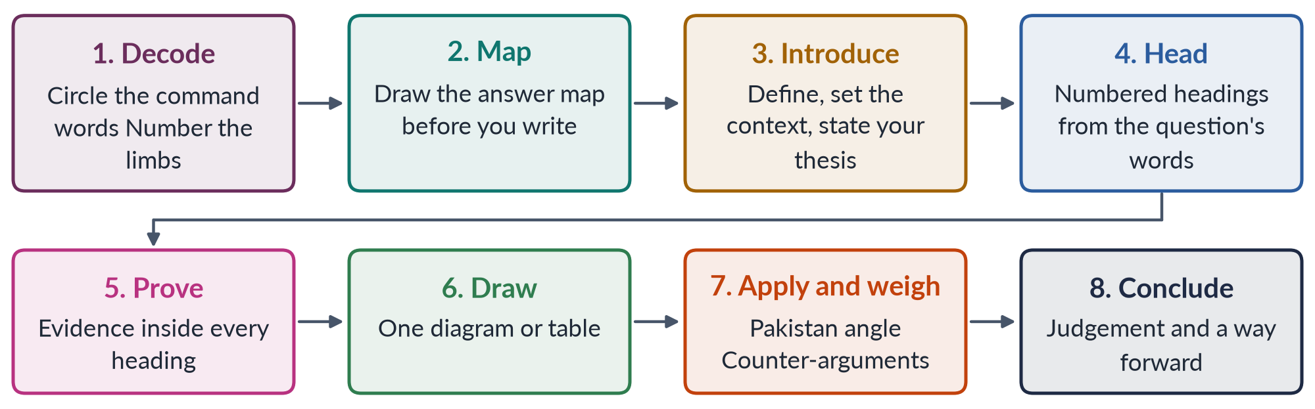
Figure 14 · The eight moves, in the order you make them.

5.3 The answer map — the house rule
Before you write a single line, spend two or three minutes drawing an answer map on the rough sheet or in the margin. The centre states what the question asks, limb by limb. Each branch is one numbered heading. Under each branch, write two or three words for the evidence you will use.
The map does three things. It makes sure you answer every limb. It gives your answer an order before you begin. And it stops you from running out of material halfway down page four. Every model answer in the QA documents begins with its map for exactly this reason.

5.4 The introduction that earns marks
A strong introduction in Gender Studies has three sentences or short paragraphs, never more than a third of a page:
1. Definition of the key term(s), ideally with a source: "Gender Studies is the interdisciplinary study of how societies construct masculinity and femininity and how these constructions shape power and opportunity."
2. Context, with one piece of evidence: "The field grew out of Women's Studies, which began at Cornell in 1969 and San Diego State in 1970 as the academic wing of the second-wave women's movement."
3. Thesis — your answer in one sentence: "Although the two fields differ in subject, aim and method, they are best understood as stages of one intellectual project rather than rivals."
TRAP · THE INTRODUCTIONS THAT LOSE MARKS
• The quotation with no connection to the question ("Behind every successful man there is a woman").
• The history lesson that starts in the Stone Age.
• The introduction that repeats the question and adds nothing.
• The introduction that never defines the central term.

5.5 Headings that repeat the question
The single most effective technique in this paper is to take your headings from the question's own words. If the question asks you to "define the terms masculinity and femininity" and then asks "where do traditional gender roles come from?", your headings are:
1. Introduction
2. Masculinity defined
3. Femininity defined
4. Where traditional gender roles come from — (i) biological explanations, (ii) socialisation, (iii) religion and culture, (iv) the economy and the division of labour, (v) the state and law
5. The Pakistani picture
6. Conclusion
The examiner can now see, in a glance down the page, that every part of the question has been answered. Number the headings (1), (2), (3); number sub-headings (i), (ii) and, if needed, (a), (b). Underline headings neatly.

5.6 Evidence — the four kinds, and how to use them
A point without evidence is an opinion. In Gender Studies there are four kinds of evidence, matching the four kinds of evidence card in these notes:
Table 39 · The four kinds of evidence and how to write them in the exam.
Kind | Example | How to write it
Thinker | Connell's hegemonic masculinity | "Raewyn Connell (Masculinities, 1995) calls the dominant ideal 'hegemonic masculinity' — the form that legitimises men's power over women."
Data | Female labour-force participation | "Only 24.4% of working-age women are in the labour force (Pakistan Labour Force Survey 2024–25)."
Law and policy | The anti-honour-killing law | "The Criminal Law (Amendment) (Offences in the Name or Pretext of Honour) Act 2016 made life imprisonment mandatory even where the family forgives."
Case | Mukhtaran Mai | "In 2002 a village panchayat in Meerwala ordered the gang rape of Mukhtaran Mai as 'punishment' for her brother's alleged offence — a textbook case of structural and direct violence combined."

Three rules for evidence:
- Put it inside the point. Never collect all your statistics in a separate paragraph at the end.
- Always name the source and year of a number. Data from 2017 presented as current is worse than no data.
- Explain what it proves. After the evidence, add a short clause: "…which shows that legal reform alone has not changed social practice." This is the arrow (➜) on every evidence card in these notes, and it is what turns a quotation into an argument.

5.7 Diagrams in a Gender Studies answer
A clear diagram earns marks in two ways: it shows understanding at a glance, and it breaks up six pages of text for a tired examiner. One diagram per answer is enough; two is the maximum. Draw with a ruler and pencil, label clearly, and give it a caption. These shapes cover almost every question:
Table 40 · The diagrams that work, and where.
Diagram | Use it for | Example
Comparison table | Define-and-differentiate questions | Women's vs Gender Studies; WID vs WAD vs GAD
Flow or evolution chart | Approaches and theories that follow each other | WID → WAD → GAD → mainstreaming
Timeline | Movements, laws, the history of quotas | The four waves; the women's movement in Pakistan
Tree | Types and schools | The schools of feminism; forms of violence
Cycle | Self-reinforcing processes | The cycle of violence; poverty–illiteracy–early marriage
Pyramid or layers | Levels of causation | Galtung's direct, structural, cultural violence; the ecological model
Spectrum | Debates with positions along a line | Nature versus nurture
Venn | Overlapping identities | Intersectionality
Bar chart | Data comparisons | Literacy by sex; women in parliament over time

5.8 The Pakistan angle and the balanced view
Nearly every question — even one that sounds purely theoretical — rewards application to Pakistan. A question on modernisation theory can end with the Green Revolution in Punjab and its effect on women's farm work. A question on postmodern feminism can discuss the plurality of women's experiences across Pakistan's provinces, classes and faiths. Keep a small set of Pakistani evidence ready for every topic; the Fact Book arranges it for you.
On sensitive questions, apply the four-step approach of §0.9: state the issue neutrally, give each side fairly, anchor your judgement in the Constitution, Pakistan's commitments and the evidence, and end with a practical way forward.

5.9 The conclusion
The conclusion is worth only a mark or two, but it is the last thing the examiner reads before writing a number. A strong conclusion does three things in four or five lines:
1. Answers the question directly — your judgement.
2. Looks forward — two or three specific, realistic recommendations or a sense of where the debate is going.
3. Ends with weight — a short line from a thinker, a leader or a report, or a crisp sentence of your own.
EXAMPLE · A CONCLUSION THAT WORKS
"Quotas have brought women into Pakistan's assemblies in numbers the country had never seen, but presence has not yet become power. The next step is not to abolish the quota but to complete it — by enforcing the 5% ticket rule, moving towards direct election to reserved seats, and giving women legislators leadership of committees beyond 'women's issues'. As Beijing put it in 1995, women's equal participation in decision-making is 'a necessary condition for women's interests to be taken into account'."

5.10 Short notes
When Question 8 asks for two short notes (10 marks each), treat each note as a miniature answer of about 550–650 words, or roughly two and a half to three handwritten pages:
1. A definition or identification in the first two lines.
2. Three to five short headed points, each with a piece of evidence.
3. One example, ideally from Pakistan.
4. A one- or two-line conclusion.
Short notes are often the best-scoring question on the paper, because the subject is narrow and a well-prepared candidate can be complete. Do not treat them as a last resort.

5.11 A worked example — CSS 2023, Question 3
"Differentiate between Gender Studies and Women's Studies. Discuss in detail the multidisciplinary nature of Gender Studies."
Step 1 — decode. Two command words: differentiate (limb 1) and discuss in detail (limb 2). Two limbs, so two main blocks of headings. "In detail" tells you the second limb carries at least half the marks.
Step 2 — map.
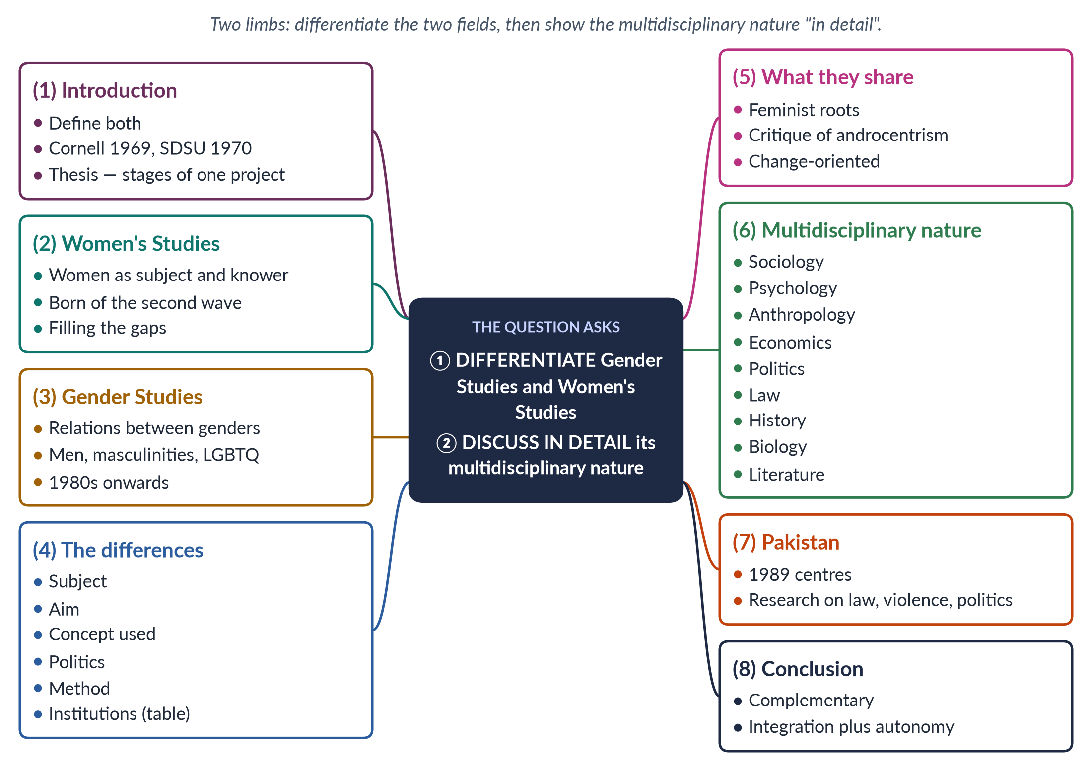
Figure 15 · The answer map for CSS 2023 Q3: every branch is a numbered heading.
Step 3 — write. The introduction defines both fields in one sentence each, gives the 1969–70 origins, and states the thesis. Headings (2) to (5) answer limb 1: two short portraits, a comparison table on six criteria, and a paragraph on what the fields share. Heading (6), the longest, answers limb 2 with one short paragraph per discipline — each naming what that discipline contributes, with one thinker or example (sociology: Oakley on housework; psychology: Bem's androgyny; anthropology: Mead's three societies; economics: Boserup and unpaid care; law: CEDAW and Pakistan's protective laws; history: recovering women's past; biology: the sex/gender debate; literature: Showalter's gynocriticism). Heading (7) brings it to Pakistan. The conclusion argues that the two fields are stages of one project and that Gender Studies' multidisciplinary nature is both its strength and the reason for the autonomy–integration debate.
Step 4 — draw. The comparison table under heading (4) is the diagram. A small wheel of disciplines around "Gender Studies" under heading (6) would be a second.

5.12 The presentation checklist
Before you hand in, spend the last five minutes on this list:
- Are the question numbers written clearly at the top of each answer?
- Are headings numbered, underlined and taken from the question's words?
- Is every key term defined?
- Does every heading contain at least one piece of evidence?
- Is there at least one diagram or table, labelled and captioned?
- Is there a Pakistan angle and a counter-argument?
- Does the conclusion give a judgement and a way forward?
- Are names spelled correctly — Malala Yousafzai, Sharmeen Obaid-Chinoy, Simone de Beauvoir, Kimberlé Crenshaw?

Part Six — The Plan
A plan turns a syllabus into a timetable. This one takes a complete beginner from the first page to the exam hall in sixteen weeks, alongside other papers.

6.1 The sixteen-week timetable
The plan assumes about 90 minutes a day, six days a week, for Gender Studies, alongside your other subjects. Order matters: T1 gives you the language of the subject, T2 its theories, and everything after that applies them. The heaviest topics get the most time.
Table 41 · Sixteen weeks from zero to the exam.
Weeks | Study | Output by the end
1 | This Master Anatomy: Part Zero slowly; Parts One–Three quickly | You can define the twelve ideas of §0.3 and explain the seven topics
2–3 | T1KB (the discipline and social construction) | Ten T1 terms defined from memory; two T1QA answers read and re-planned
4–5 | T2KB (feminist theories) | A one-page table of the schools from memory; one practice answer written
6–7 | T3KB (movements) | The waves and the Pakistani phases drawn as timelines; one practice answer
8–10 | T4KB (gender and development) — three weeks, the heaviest topic | WID/WAD/GAD table and the theory comparison from memory; two practice answers
11 | T5KB (status of women in Pakistan) | A one-page data sheet from the Fact Book; one practice answer
12 | T6KB (governance) | The quota history timeline; one practice answer
13 | T7KB (violence and the case studies) | The laws list and the three case studies from memory; one practice answer
14 | All seven TnQA documents: re-plan every past question as an answer map | 84 answer maps (two or three minutes each)
15 | Prediction Papers Sets 1 and 2 under timed conditions; OL bank | Two full papers written and self-marked with §1.5
16 | Revision Notes; Fact Book; Prediction Paper Set 3; MCQ drills | The exam-day plan rehearsed

6.2 The daily routine
Table 42 · A ninety-minute study session.
Minutes | What you do
10 | Revise yesterday: close the book and write the key terms and one diagram from memory.
50 | Read today's section of the Knowledge Base. Stop at every card and say aloud what it proves.
15 | Plan one past question from the topic as an answer map — without looking at the model.
15 | Compare with the model's map; note what you missed. Add three facts to your personal list.

Once a week, write one full answer in thirty minutes by hand. Writing is a separate skill from knowing; it improves only with practice.

6.3 The memory routine — using the Fact Book
The subject has perhaps five hundred facts worth knowing: dates, numbers, names, laws and books. Do not try to learn them all at once.
1. Learn the facts inside their arguments. A date remembered as part of a story (WAF formed in 1981 because of the Hudood Ordinances of 1979) stays; a date in a list fades.
2. Use the Fact Book by topic, a page a day, from the week you finish each Knowledge Base.
3. Use spaced repetition. Review a page after one day, three days, a week, and a month.
4. Keep a "numbers card" — one card with the fifteen statistics you will use most (literacy, labour participation, maternal mortality, the gender-gap rank, women's seats, the electoral gender gap). Update it from the Fact Book before the exam.

6.4 The objective part
- Read the one-liner bank at the end of each Knowledge Base on the day you finish it.
- Do all 140 past MCQs in the OL volume once in week 14 and again in week 16.
- Concentrate on T1 and T2 names and terms — they supply nearly two in five MCQs.
- Keep the laws and dates list (from the Fact Book) on your wall.

6.5 The last fortnight
1. Read Part Three of this document again. Decide your Tier 1 list.
2. Re-read the Revision Notes twice, a topic a day.
3. Write the three Prediction Papers under exam conditions if you have not already.
4. Re-draw from memory the ten diagrams you will most likely use: the sex/gender comparison, the schools of feminism, the waves timeline, the Pakistani movement timeline, WID → WAD → GAD, the development theories table, the quota history, Galtung's triangle, the ecological model, the cycle of violence.
5. Update your numbers card from the Fact Book.

6.6 The day of the paper
Table 43 · The day of the paper, minute by minute.
Time | What you do
The night before | Numbers card; the ten diagrams; sleep. Do not start anything new.
Before entering | Pens (blue or black), pencil, ruler, eraser, admit card, CNIC, water.
Minutes 0–25 | Part I: all twenty MCQs. Mark doubtful items; return to them; leave nothing blank.
Minutes 25–35 | Read all seven questions twice. Choose four. Start with your strongest.
Each answer (~33 min) | 3 minutes map; 28 minutes write; 2 minutes check.
Last 8 minutes | Numbers and headings check; underline key terms; make sure all four answers are complete.

EXAMINER'S EYE · IF A QUESTION SURPRISES YOU
If a question uses a term you do not recognise, look at its other words: most "new" questions are old families in new clothing. 2026 Q6 (NGO-isation) is the Pakistani movement plus the WAD critique; 2026 Q4 (the gender gap report) is the status of women with a new frame. Map it on to what you know, define the new term as best you can from its context, and answer the limbs you can answer fully.

Appendix A — Every Descriptive Question, 2016–2026, by Year
The questions are given as set, with light standardisation of spelling and punctuation, from the past-paper volume in this folder. The last column shows the topic and family used throughout this document. A short-note question is split into its parts.

CSS 2016
Q | The question | Topic · family
Q2 | Write a note on the status of women's studies in Pakistan and give your views on the autonomy/integration debate in Women's Studies. | T1 · Status of Gender / Women's Studies in Pakistan; The autonomy versus integration debate
Q3 | What are the sites and forms of violence against women in Pakistan and how in your view this menace can be eliminated from our society? | T7 · GBV — forms, sites and strategies to eliminate it
Q4 | What are the pros and cons of gender quota in politics? Give your views on the impact of gender quota in politics in Pakistan. | T6 · Political quotas for women
Q5 | Write a note on women's movement in Pakistan. What are its strengths and weaknesses? | T3 · The women's movement in Pakistan
Q6 | What are the theories of social construction of gender? | T1 · Social construction of gender — theories; deconstructing 'gender'
Q7 | What is feminism? In what way is Radical Feminism different from Socialist Feminism? | T2 · What is feminism; schools of feminism compared; Radical feminism; Marxist / socialist feminism
Q8 | Critically review the Gender and Development approaches: (i) Women in Development (WID), (ii) Women and Development (WAD), and (iii) Gender and Development (GAD). | T4 · WID, WAD and GAD

CSS 2017
Q | The question | Topic · family
Q2 | Define and discuss the discipline of Gender Studies and also differentiate between Women's Studies and Gender Studies. | T1 · Gender Studies as a discipline — meaning, need, scope; Women's Studies versus Gender Studies
Q3 | What are the different forms of gender-based violence and, in your opinion, what could be the workable strategies to eliminate gender-based violence from Pakistani society? | T7 · GBV — forms, sites and strategies to eliminate it
Q4 | 'Women's active political participation could stabilize democracy and boost economic development.' Comment on this statement within the context of the socio-economic realities of Pakistani society. | T6 · Women's political participation
Q5 | What is the status of women's health in Pakistan? How could it be improved within the available economic resources? | T5 · Women's health in Pakistan
Q6 | 'Powerful forces of globalization have highlighted various gender issues across cultures and throughout the globe.' Discuss by quoting examples from developing countries. | T4 · Globalisation and gender
Q7 | Write a comprehensive note on the autonomy versus integration debate in Gender Studies. | T1 · The autonomy versus integration debate
Q8(a) | Short note — Honour killing | T7 · Honour killing
Q8(b) | Short note — Gender and development | T4 · WID, WAD and GAD

CSS 2018
Q | The question | Topic · family
Q2 | What are the fundamental differences between Gender Studies and Women's Studies? Substantiate your argument(s) with examples. Highlight the current status of Women's Studies in Pakistan. | T1 · Women's Studies versus Gender Studies; Status of Gender / Women's Studies in Pakistan
Q3 | Write a comprehensive essay on the 'sex versus gender debate' in feminist philosophy and social sciences, reflecting the nature versus nurture argument. | T1 · Sex versus gender; is sex socially constructed; nature versus nurture
Q4 | What type(s) of feminism can elevate the socio-cultural, economic and political status of women in Pakistan? | T2 · Which feminism suits Pakistan
Q5 | What reasons are responsible for ranking Pakistan as the second-worst country in the world for gender inequality despite Pakistan's commitment to many international conventions and the strong commitment to gender equality in the 1973 Constitution? | T5 · Pakistan and the Global Gender Gap; Women, law and human rights
Q6 | In the last two decades, globalization has had a huge impact on the lives of women in developing nations, including Pakistan. What are the impacts of the global political economy on Pakistani women? | T4 · Globalisation and gender
Q7 | Believing in the statement that 'women cover half the sky', do you think we need an equal number of women in all spheres of the public domain, especially in politics? | T6 · Women's political participation
Q8(a) | Short note — Gender Strategic Needs and Gender Practical Needs | T4 · Practical and strategic gender needs
Q8(b) | Short note — APWA and WAF | T3 · APWA and WAF
Q8(c) | Short note — Government initiatives for combating violence against women | T7 · GBV — laws and state initiatives

CSS 2019
Q | The question | Topic · family
Q2 | How do you differentiate the discipline of Gender Studies from that of Women's Studies? Historically trace the need for the establishment of Gender Studies as a distinct discipline and its scope and significance, with special reference to Pakistan. | T1 · Gender Studies as a discipline — meaning, need, scope; Women's Studies versus Gender Studies; Status of Gender / Women's Studies in Pakistan
Q3 | Outline and explain the three major waves of feminist movements in the West. Discuss the influence of these waves on feminist movements in Pakistan. | T3 · The waves of Western feminism and their influence on Pakistan
Q4 | Explain the relevance of Modernization Theory and Dependency Theory to gender equality. Critically analyze the subordination of women in modern societies in the light of these two theories. | T4 · Modernisation (and dependency) theory; Gender analysis of development theories
Q5 | The process of globalization has connected nations worldwide and made the world a global village, yet it has also increased inequalities across nations. Discuss the gendered inequalities created and promoted by globalization in contemporary societies worldwide. | T4 · Globalisation and gender
Q6 | Women's participation in the labour force has increased recently, yet women continue to perform their reproductive roles. Discuss the challenges encountered by women as a result of paid employment worldwide, with special reference to Pakistan. | T5 · Women and paid employment
Q7 | Explain the structural and direct forms of violence against women in Pakistani society by highlighting the case study of Mukhtaran Mai. | T7 · GBV — forms, sites and strategies to eliminate it; Case study — Mukhtaran Mai
Q8(a) | Short note — Suffragist movement | T6 · The suffragist movement
Q8(b) | Short note — Postmodern Feminism | T2 · Postmodern feminism
Q8(c) | Short note — Structural Functionalism | T4 · Structural functionalism

CSS 2020
Q | The question | Topic · family
Q2 | Gender has multiple meanings. How do you deconstruct the word 'GENDER'? | T1 · Social construction of gender — theories; deconstructing 'gender'; Sex versus gender; is sex socially constructed; nature versus nurture
Q3 | How did the colonial era influence the status of women in the subcontinent? | T4 · Colonial and capitalist perspectives of gender
Q4 | 'Language is gendered.' What does this imply? Explain with examples. | T1 · Gendered language
Q5 | Women need to be in leadership positions to pull more women into leadership roles. Is this suggestion that women need to 'pull each other up' useful, or is it inappropriate preferential treatment? | T6 · Women in leadership
Q6 | 'For realizing, in letter and spirit, the ideals of a democratic welfare state, it is necessary to institute a system which fully guarantees human rights, generates a conducive environment for the pragmatic use and beneficial enjoyment of human rights, and provides operative safeguards and expeditious remedy against any violation of human rights.' Critically evaluate the statement with special reference to Pakistan. | T5 · Women, law and human rights
Q7 | Comment on the power-and-control relationship in gender-based violence. | T7 · GBV — causes, theories, power and control
Q8 | Discuss the background of the two Oscar-winning documentaries by Sharmeen Obaid-Chinoy. | T7 · Case study — Sharmeen Obaid-Chinoy

CSS 2021
Q | The question | Topic · family
Q2 | Discuss in detail how the autonomy and integration debate in Gender Studies has made an important contribution to the development of the field of knowledge. | T1 · The autonomy versus integration debate
Q3 | Masculinity and femininity are deeply engraved realities since the distant past in human history. Discuss various theoretical debates on their construction to make explicit whether the formation of both is a natural or social reality. Support your arguments with real-life examples. | T1 · Masculinities, femininities and gender roles; Sex versus gender; is sex socially constructed; nature versus nurture
Q4 | Marxist feminism is a philosophical variant of feminism that incorporates and extends Marxist theory and analyzes the ways in which women are exploited through capitalism and the individual ownership of private property. Discuss the development of Marxist/Socialist feminism and the philosophical stance it holds on gender issues and exploitation. | T2 · Marxist / socialist feminism
Q5 | Psychoanalytic feminism is a theory of oppression which asserts that men have an inherent psychological need to subjugate women. Give a detailed analysis of gender oppression and women's subordination promulgated by Psychoanalytic Feminism. | T2 · Psychoanalytic feminism
Q6 | Modernization Theory blames internal cultural factors for women's subordination in the developing world. Discuss and elaborate the statement in respect of Modernization perspectives. | T4 · Modernisation (and dependency) theory
Q7 | Critically analyze the various approaches to women's development, focusing on Women in Development (WID), Women and Development (WAD), and Gender and Development (GAD). | T4 · WID, WAD and GAD
Q8 | Despite the entry of women legislators into politics on a 17 percent quota in national and provincial assemblies, there are still voices asking, 'Is Pakistan's gender quota in parliament showing results?' Rethink and discuss how quotas can lead to the political mainstreaming of women in Pakistan. | T6 · Political quotas for women

CSS 2022
Q | The question | Topic · family
Q2 | Discuss in detail the multidisciplinary nature of Gender Studies. | T1 · The multidisciplinary nature of Gender Studies
Q3 | Describe any two Western schools of thought about feminism in detail. | T2 · What is feminism; schools of feminism compared
Q4 | Shed light on the first wave and third wave of feminism. | T3 · The waves of Western feminism and their influence on Pakistan
Q5 | In your opinion, what are the main issues faced by women as representatives in Pakistan? | T6 · Women as representatives / politicians
Q6 | Discuss in detail feminist movements in Pakistan. | T3 · The women's movement in Pakistan
Q7 | What are the capitalistic perspectives of gender? Explain. | T4 · Colonial and capitalist perspectives of gender
Q8 | Discuss in detail the gender critique of Structural Adjustment Policies (SAPs). | T4 · Gender critique of Structural Adjustment Policies

CSS 2023
Q | The question | Topic · family
Q2 | Write a note on the status of Gender Studies in Pakistan. Give your views on the autonomy versus integration debate in Gender Studies. | T1 · Status of Gender / Women's Studies in Pakistan; The autonomy versus integration debate
Q3 | Differentiate between Gender Studies and Women's Studies. Discuss in detail the multidisciplinary nature of Gender Studies. | T1 · Women's Studies versus Gender Studies; The multidisciplinary nature of Gender Studies
Q4 | Define the terms masculinity and femininity. In your opinion, where do traditional gender roles come from? | T1 · Masculinities, femininities and gender roles
Q5 | Outline and explain the three major waves of feminist movements in the West. Discuss the influence of these waves on feminist movements in Pakistan. | T3 · The waves of Western feminism and their influence on Pakistan
Q6 | Write a detailed note on the colonial and capitalistic perspectives of gender. | T4 · Colonial and capitalist perspectives of gender
Q7 | Elucidate the current health status of women in Pakistan. What measures could be taken to improve women's status as a whole? Support your arguments with suitable examples. | T5 · Women's health in Pakistan
Q8 | Define gender-based violence. Explain various forms of violence against women in Pakistan and devise practical strategies helpful in eradicating gender-based violence from our society. | T7 · GBV — forms, sites and strategies to eliminate it

CSS 2024
Q | The question | Topic · family
Q2 | An Egyptian doctor, Mahmoud Fathalla, uses the term 'maternity death road' while discussing issues of women's maternal health. Discuss women's health issues in the context of Pakistan's social, cultural and demographic situation. | T5 · Women's health in Pakistan
Q3 | Write a note on the colonial and capitalistic perspectives of gender. Throw light on the thesis that development is the new name of coloniality in the context of emerging perspectives of gender. | T4 · Colonial and capitalist perspectives of gender
Q4 | Write in detail the impact of Western feminist movements on the feminist movement in Pakistan. Compare Pakistani feminist movements of the past with emerging trends of feminist activism and their effects. | T3 · The waves of Western feminism and their influence on Pakistan; The women's movement in Pakistan
Q5 | Give a critical gender analysis of development theories. | T4 · Gender analysis of development theories
Q6 | What is gender-based violence? What forms of gender-based violence are given in the Punjab Protection of Women Against Violence Act 2016? What are the consequences of gender-based violence for women? | T7 · GBV — laws and state initiatives; GBV — forms, sites and strategies to eliminate it
Q7 | Is political participation a human right? If so, what obstacles are faced by women politicians in Pakistan in pursuing a career in politics? What is the impact of the political quota system on this? | T6 · Women's political participation; Political quotas for women
Q8(a) | Short note — Is 'sex' also a social construct? | T1 · Sex versus gender; is sex socially constructed; nature versus nurture
Q8(b) | Short note — Radical Feminism | T2 · Radical feminism

CSS 2025
Q | The question | Topic · family
Q2 | What are the root causes that lead to gender-based violence? How do these factors intersect and perpetuate violence against women in Pakistan? | T7 · GBV — causes, theories, power and control
Q3 | Critically evaluate the concept of 'gendered globalisation', focusing on World-System Theory and how the globalisation of capitalism has created new forms of patriarchal power that increase gender inequalities. | T4 · Globalisation and gender; Gender analysis of development theories
Q4 | Discuss the key principles, goals and strategies of the different waves of feminism. How have these waves affected women's lives? | T3 · The waves of Western feminism and their influence on Pakistan
Q5 | Elaborate the historical context and evolution of women's quota in Pakistan concerning key legislation and policies that have shaped the quota system. | T6 · Political quotas for women
Q6 | Give a detailed analysis of the intersectionality of gender with other social identities. | T2 · Intersectionality
Q7 | Critically analyze Women in Development (WID) and Gender and Development (GAD) models. Discuss their basic principles and limitations in addressing women's needs in developing countries. | T4 · WID, WAD and GAD
Q8 | Critically examine and evaluate Malala Yousafzai's achievements and activism for promoting girls' education in local and global contexts. | T7 · Case study — Malala Yousafzai

CSS 2026
Q | The question | Topic · family
Q2 | Critically examine the theoretical arguments of social constructionism and queer theory regarding the categories of sex and gender. How do these arguments illuminate contemporary debates about transgender rights and the controversies over the Transgender Persons (Protection of Rights) Act 2018 in Pakistan? Support your answer with examples from legal debates and activism. | T1 · Queer theory and transgender rights; Social construction of gender — theories; deconstructing 'gender'
Q3 | Trace the evolution of the feminist movement in Pakistan, from the activism of the Women's Action Forum (WAF) against the Hudood Ordinances in the 1980s to the digital activism of the 2020s. How has the locus of resistance shifted from 'legal rights' to 'bodily autonomy'? | T3 · The women's movement in Pakistan
Q4 | Evaluate Pakistan's performance in the World Economic Forum's Global Gender Gap Report 2025. Identify the socio-economic and political factors contributing to Pakistan's ranking, including labour-force participation, education, health and political empowerment. | T5 · Pakistan and the Global Gender Gap
Q5 | Climate change has gendered impacts. Drawing on feminist environmentalism and ecofeminist perspectives, critically analyse how recent floods and heat waves in Pakistan have affected women differently. | T4 · Gender, climate change and ecofeminism
Q6 | Critically examine the 'NGO-ization' of the women's movement in Pakistan. Has the donor-driven agenda of gender mainstreaming depoliticized the feminist struggle, converting it into a technocratic 'project' rather than a social revolution? Use the WAD (Women and Development) critique in your answer. | T3 · NGO-isation of the women's movement; WID, WAD and GAD
Q7 | Using intersectionality as an analytical framework, examine the experiences of marginalized groups of women in Pakistan, including rural women, ethnic and religious minorities, and differently-abled women. How do overlapping systems of oppression shape their access to health, education and employment? | T5 · Intersectionality
Q8(a) | Short note — Gendered implications of digital transformation and the narrowing mobile gender gap in Pakistan (2024-2025), including the fact that eight million more women came online and the mobile internet gender gap fell from 38% to 25% | T5 · The digital gender gap
Q8(b) | Short note — The role of masculinity studies in understanding violence against women in Pakistani society | T7 · Masculinities and violence against women

Appendix B — The Prediction Paper Format
The three Prediction Papers are set exactly as FPSC prints the Gender Studies paper, so that practising them is practising the real thing.
Table 44 · The format of each Prediction Paper.
Element | Format
Heading | FEDERAL PUBLIC SERVICE COMMISSION · COMPETITIVE EXAMINATION FOR RECRUITMENT TO POSTS IN BS-17 UNDER THE FEDERAL GOVERNMENT · GENDER STUDIES
Time and marks | Time allowed: three hours. Part I (MCQs): maximum 30 minutes, 20 marks. Part II: 80 marks
Instructions | Part II to be attempted on the separate answer book; attempt only four questions from Part II; all questions carry equal marks; answers in English
Part I | Q.1: twenty MCQs, options (A) to (D), one mark each, spread across all seven topics and weighted like the recent objective papers (more theory than facts)
Part II | Q.2 to Q.8, 20 marks each; one question of two short notes (10 marks each); at least one question from each of T1, T4 and T7; at least one blind-spot question and at least one contemporary-layer question per set
After each set | The MCQ key with a one-line explanation for every item; full model answers (1,000–1,300 words each; short notes 550–650 words) in the house format — answer map, decoding, model answer, why it scores

Across the three sets the 21 descriptive questions will be spread over all seven topics in proportion to the record, with Tier 1 families appearing in new forms, all Tier 3 blind spots appearing at least once, and the contemporary layer (climate, the digital gap, the 2025–2026 laws, Beijing+30, intersectionality) represented in every set.

Appendix C — Sources and Editorial Note

The record
- The descriptive questions and MCQs are taken from the two past-paper volumes in the folder CSS_GS_PP_Gender Studies_Past Papers (descriptive 2015–2026; MCQs 2015–2026). The MCQ sheets for 2017, 2020, 2021 and 2022 could not be recovered from reliable archives; no substitute has been invented.
- The syllabus is FPSC's Revised Scheme and Syllabus for CSS Competitive Examination (for CE-2016 and onwards), in the folder CSS Syllabus.
- All tagging (topics, families, command words, leaks) is editorial. A full question counts as one visit; a short-note part as half.

The facts
The facts in this document are current to September 2026. The principal sources are:
- World Economic Forum, Global Gender Gap Report 2026 and 2025 (Pakistan 143rd of 145 in 2026, score 59.5%; 148th of 148 in 2025, score 56.7%).
- Pakistan Bureau of Statistics: Census 2023 (literacy 60.65% overall; about 68% men and 53% women); Labour Force Survey 2024–25 (female labour-force participation 24.4%).
- National Institute of Population Studies, Pakistan Maternal Mortality Survey 2019 (maternal mortality ratio 186 per 100,000 live births).
- Election Commission of Pakistan, General Elections 2024 (11 women elected to general National Assembly seats).
- Islamabad Capital Territory Child Marriage Restraint Act 2025 (assented 30 May 2025); Federal Shariat Court judgment on the Transgender Persons (Protection of Rights) Act 2018 (19 May 2023) and the pending appeal before the Shariat Appellate Bench of the Supreme Court.
- The FPSC reading list (§1.3), and the standard works named in the thinkers table (§0.5).

Editorial rules
- No quotation is invented; famous lines are quoted only where the wording is established.
- Statistics carry their source and year. Where sources differ (for example, labour-force participation measured under different international definitions), the notes give the official Pakistani figure and say so.
- Contested questions are presented in balance; the notes take the position that can be defended from the Constitution, Pakistan's international commitments and the evidence.
- Facts that change (rankings, laws, data) are refreshed in the Fact Book, which is the last volume of the set to be finalised before each examination.

